Title: Projected land-cover changes and their consequences on the supply of Ecosystem Services in Uruguay

Abstract
Grasslands are one of the most human-modified biomes in the world due to the expansion of croplands and afforestation. In the scenario of productive intensification, it is necessary to generate alternatives to model land-cover changes and their environmental consequences. The objective of this study was to generate land-cover projections and quantify the future impact of these dynamics on the supply of ecosystem services in Uruguay. For that, land-cover maps, Markov-chains models, and an index of the supply of ecosystem services (ESSI) were utilized. Based on the land-cover maps, transitions probabilities between classes for two time periods (2000–2010 and 2010-2019) were calculated, and two Markovian-chain models were performed. With the projected land-cover maps, spatial models were used to relate the proportion of croplands and grasslands with the ESSI. The results indicate a continuous increase of croplands and afforestation for the next decade. Grasslands will remain the most abundant land-cover, reaching 46% in 2037. The highest probability of persistence was, in both periods, for grasslands, while the probability of persistence increased by 60 and 13% for croplands and afforestation, respectively. The ESSI shows a 5% of decrease between 2000-2037. These findings provide important empirical evidence for territorial planning and sustainable management.
Keywords: Ecosystem Service Supply Index, Grasslands, Markovian models, NDVI, Territorial planning.

- Introduction
Grasslands, savannas and shrublands are one of the most human-modified biomes in the world. They are widely distributed occupying around one-third of the planet´s land surface (White et al. 2000, Dixon et al. 2014, Bond, 2019). In addition to housing the most productive agricultural lands, this biome offers crucial Ecosystem Services (ES), including climate regulation via carbon sequestration, clean water provision, defence against biological invasions, protection against soil erosion and flooding, cultural heritage, tourism, among others (Sala and Paruelo, 1997, Zhao et al. 2020). However, the transformation of this biome into croplands, tree plantations, mining areas and urban expanses has made them among the most altered and threatened ecosystems on a global scale (Henwood, 1998, Ellis and Ramankutty, 2008, Parr et al. 2014, Carbutt et al. 2017). In fact, approximately 45.8 % of the grasslands, savannas and shrublands worldwide have been converted (Hoeckstra et al. 2005). In addition, these biomes have the lowest Conservation Risk Index value (calculated as the ratio of percent area converted to percent area protected), placing them in the "Endangered" and "critically endangered" biome categories (Hoekstra et al. 2005).
Despite their significance, grasslands have received little international recognition (Veldman et al. 2015), especially when compared to other ecosystem like woodlands or wetlands (Stanturf et al. 2019, Brancalion and Holl, 2020). Moreover, grasslands have been largely disregarded in local conservation and research agendas (Parr et al. 2014, Overbeck et al. 2022) as well as in global policy discussions (especially those relating to ES supply, e.g. IPBES, Díaz et al. 2015). The lack of recognition and understanding of their ecological and socio-economic importance creates an even worse scenario for grasslands, which may result in greater conversion to other land-uses, leading to the loss of important ES.
Assessing the environmental consequences of the transforming natural ecosystem, such as grasslands, into anthropogenized ecosystems, such as croplands and afforestations, requires quantifying the level of ES supply (Paruelo and Sierra, 2022). Based on Boyd and Banzhaf (2007), Fisher et al. (2009) defined ES as “those aspects of the ecosystem that actively or passively, directly or indirectly, contribute to human well-being”. However, operationalizing this concept is challenging for several reasons. Perhaps, the methodological aspects involved in characterizing and quantifying the ES supply are the most relevant. To address this challenge, Paruelo et al. (2016) proposed the Ecosystem Services Provision Index (called ESSI by Staiano et al. 2021) as a comprehensive estimator of the supply of supporting and regulating ES, mainly those associated with water and carbon dynamics. The index is generated from ecosystem functional attributes and estimated using spectral data from satellite-based remote sensing, which can cover very broad spatial and temporal scales at a low cost and based on the same observation protocol (Paruelo, 2008). Staiano et al. (2021) recently summarized the application of the ESSI in the socio-ecosystem diagnosis, monitoring, and territorial planning stages for 8 existing study cases (3 of them in grasslands). The authors found that the ESSI was successfully applied and helped to better define interventions in management decisions. Baldassini et al. (2022) also used the ESSI to estimate the C stock of non-forested areas of Uruguay.
One of the greatest areas of natural grasslands in the world and the most significant in South America is the Río de la Plata Grasslands, which span across Argentina, Uruguay, and Brazil (Soriano, 1991, Paruelo et al. 2007, Oyarzabal et al. 2020). The natural vegetation has a remarkable floristic diversity (Andrade et al. 2018; Lezama et al. 2019) and has historically been utilized as a source of forage for extensive livestock activity. Meat production for both domestic consumption and export is a crucial economic activity for the countries that constitute this region (Modernel et al. 2016). However, the unprecedented replacement rates due to the expansion of croplands and tree plantations, puts this region among the most vulnerable globally (Paruelo et al. 2006, Baldi and Paruelo, 2008, Vega et al. 2009, Volante et al. 2015, Modernel et al. 2016, Baeza and Paruelo, 2020, Baeza et al. 2022). Land-cover changes in the Río de la Plata Grasslands region have had significant impacts on ES supply. Numerous studies have found negative effects on the carbon gains dynamic (Texeira et al. 2015, Vasallo et al. 2013), water regulation (Nosetto et al. 2005, Jobbágy et al. 2006, Silveira et al. 2016), landscape fragmentation (Baldi and Paruelo, 2008, Ríos et al. 2022), and soil organic carbon content (Caride et al. 2012, Céspedes-Payret et al. 2012, Baldassini et al. 2022). Also, more than 40% of the annual carbon gains appropriated by humans were the result of these changes (Baeza and Paruelo, 2018, Paruelo et al. 2019).
The Río de la Plata Grasslands region is currently under high pressure, therefore, during the next several years, the land-cover changes may continue to shift dramatically. The growing demand for grains, cellulose, and other primary products, combined with the lack of public policies, the international price of commodities and technological advances, that allow the expansion of alternatives used on more marginal areas, are some of the most important controls of land conversion (Paruelo et al. 2006, Redo et al. 2012, Gorosábel et al. 2020). In this sense, spatially explicit modelling of land-cover changes provides an important basis in terms of decision-making. However, there are few precedents in the region that have generated predictive models of land-cover change. Vega et al. (2009), based on Markovian models and working at a regional subunit resolution, found that croplands would maintain the increasing trends for the whole region while afforestation cover will experience the largest relative change, particularly in Uruguay and Argentina. Unfortunately, this projected trend has been observed over the time (Baeza and Paruelo, 2020, Baeza et al. 2022).
Among the countries that constitute the Río de la Plata Grasslands region, Uruguay maintains the largest relative grasslands coverage. Currently, grasslands represent approximately 55% of the Uruguayan land surface (Baeza and Paruelo, 2020, Baeza et al. 2022) which are entirely devoted to extensive livestock production, mainly cattle and sheep (Gutiérrez et al. 2020). However, the ecosystem faces significant threats, including conversion to croplands and tree plantations (Paruelo et al. 2006), as well as degradation from overgrazing and invasive alien species (Altesor et al. 2019; Tiscornia et al., 2019)Within the first one, official statistics and remotely-sensed data showed that the area covered by grasslands has decreased at alarming rates, from 80% to 55% between 1990 and 2019 (DIEA-MGAP, 2011, Baeza et al. 2022). In a global and regional scenario of productive intensification, it is necessary to generate alternatives to model land-cover changes and their environmental consequences. In this study, projections were generated, at a resolution of 2500 ha, based on observed trends in land-cover changes and the impact of these dynamics on the future supply of ES in Uruguay was quantified. For that, land-cover maps from the MapBiomas Pampa Initiative (MapBiomas, 2022; Baeza et al. 2022), Markov chains models, and remote sensing data to calculate the Ecosystem Service Supply Index were used.
This study specifically addresses the following questions:
- What will be in Uruguay the main land-cover changes in the coming decades based on observed trends?
- What will be the effects of the land-cover changes on the supply of ecosystem services?

- Methods
  - Study area
Uruguay is located between the latitude 30° - 34° S and longitude 53° - 58° W and covers a continental area of 176.215 km² (Figure 1). The climate is temperate with a mean-annual temperature of 17.5 °C and a mean-annual precipitation of 1300 mm/y⁻¹. The temperature exhibits a strong seasonal variation, with minimums and maximums of 6 (July) and 28 °C (January), respectively. Precipitation is distributed uniformly throughout the year, but it is strongly variable between years (i.e., 700 mm in 1989 and 2000 mm in 2002; INUMET, 2022). Most of the land is privately owned by Uruguayan farmers and large corporations (Modernel et al. 2016).

  - Land-cover maps
Land-cover (LC) maps from the MapBiomas Pampa Initiative (MapBiomas, 2022; Baeza et al. 2022) were used. This initiative generates annual LC maps from 2000-2019 with 30-meter resolution for the entire region of the Río de la Plata Grassland, based on Landsat images. The LC maps discriminate between seven classes: native woody formation, forest plantation, swampy areas and flooded grassland, grassland, farming, non-vegetated area, and water. Annual LC maps for Uruguay and for the 2000, 2010 and 2019 (start, end and intermediate date of the period described by MapBiomas Pampa Initiative; Figure 1) were used.
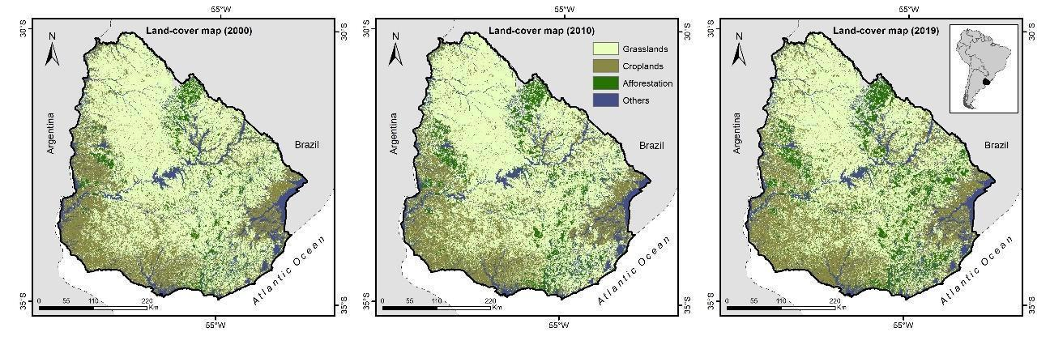
Figure 1: Land-cover maps for Uruguay in 2000, 2010 and 2019 (left to right). Data from MapBiomas Pampa Initiative.
Based on the maps, the transitions between four LC in two time periods, 2000-2010 and 2010-2019, were calculated at pixel level. The four LC classes analysed were: farming (hereafter croplands, Cr), grasslands (Gr), tree plantations (hereafter Afforestation, Af) and Other (a heterogeneous class that includes native woody formation, swampy areas and flooded grassland, non-vegetated area, and water). A 5x5 km grid covering all Uruguay (n=6856) was overlayed on the transition’s maps and transition probabilities (transition matrix) were calculated for each period. Each matrix represents either the probability of persistence of each LC class from the first to the last year of the period, or the probabilities of transition to another land-cover class during the same period.
$$p_{i→j,k}=\frac{A_{i→j,k}}{A_{i,t=0,k}}$$
where A_{i} is the area occupied by LC class i, A_{i->j} is the area of transition class i🡪 j, t=0 is the first study period, and k is a grid cell.

  - Markov chain model
Transition matrices were used to generate a simulation of the proportion of each LC, for 2028 and 2037, that could be reached in a stable state if conditions were stationary (no change in the drivers operating through time). Markov chains can be parameterized by empirically calculating transition probabilities between discrete states in the observed system because they are stochastic processes (Balzter, 2000). The LC characterization was assessed through the comparison of cover type proportions in each 5x5 km grid. A transition matrix (A) was created based on all the proportional changes from one cover type to another (a_{ij}). With A, we generate a land-cover change model as: A x n(t) = n(t+1), where n represent the vector of the relative proportions of each land-cover class. The analyses were performed in R with the “markovchain” package.

  - ESSI calculation and prediction
We calculated, for each 5x5 km grid and for the 2000, 2010 and 2019 (years coincident with the land-cover maps), the mean Ecosystem Services Supply Index (ESSI, Paruelo et al. 2016) as:

$ESSI = {NDVI}_{mean}* (1-{NDVI}_{CV})$

where NDVI_{mean} is the annual Normalized Difference Vegetation Index average (a proxy of total C gains) and NDVI_{cv} is the Normalized Difference Vegetation Index coefficient of variation (an indicator of seasonality).
The ESSI was calculated by estimating the annual average and the intra-annual coefficient of variation for each 5x5 km grid, for the years 2000, 2010 and 2019. NDVI images from the MODIS sensor (collection 6, Mod13q1) were used. These images have a 250-meter spatial resolution (~6 ha) and 16 –day temporal resolution. Each NDVI image was filtered using its associated “per pixel” quality band (Roy et al. 2002), and only those pixels without clouds or shadows, and with low levels of aerosols in the atmosphere were analysed. Simple linear interpolation from the previous and following dates of the same pixel was used to replace the values of the lowest quality pixels. The NDVI_{mean} and NDVI_{cv} values were normalized (0-1) according to their minimum (percentile 1) and maximum (99 percentile) value. All the calculations were performed on the Google Earth Engine platform (Gorelick et al. 2017)
The proportion of croplands and grasslands was compared with the ESSI for all years and at the grid scale using spatial models. Afforestation grids (<10%) were excluded, as the ESSI was designed to be used in non-forested areas. As a first step, the Variance Inflation Factor (VIF) was calculated for collinearity diagnosis (Fox and Weisberg, 2011). Since the VIF values were less than 5, there was no correlation among the predictor variables (Zuur et al. 2009). Spatial generalized least squares (GLS) models with a spatial correlation structure in residuals were used (Zuur et al. 2009). The analysis was performed in R, with the “car”, “MuMIn”, “nlme”, “gstat”, “sp”, and “bbmle” packages. The spatial correlations of five different (and more commonly used) structures (spherical, gaussian, linear, exponential, and exponential), were evaluated (Zuur et al. 2009) and the best one for the study area was determined using the Akaike Information Criteria (AIC). The exponential spatial autocorrelation structure was the best for the study area. Additionally, a restricted maximum likelihood adjustment was made to the model (Gurka, 2006). The goodness of fit of the model was calculated based on the log likelihood-ratio test, based on the ‘‘r.squaredLR” function of the “MuMIN” R package. The value was adjusted with Nagelkerke modification so that R² achieves 1 at its maximum (Nagelkerke, 1991).

- Results

  - Markovian models
Markov chain models showed differences between the analysed periods but with some patterns in common (Figure 2). In both periods, grasslands showed the highest probability of persistence (0.76 and 0.72 for 2000-2010 and 2010-2019, respectively) and the lowest spatial variability in persistence (±0.24 and ±0.22 for 2000-2010 and 2010-2019, respectively). The probability of persistence decreased 5 % between periods for grasslands while it increased by 60 and 13 % for croplands and afforestation, respectively. Croplands were the class with the highest spatial variability in both periods (±0.31 and ±0.32, respectively). On the other hand, the highest transition probability was for Cr→Gr and this occurred for both periods. This probability decreased by 56 % between periods. Similarly, afforestation also showed a similar pattern, with a decrease in the transition probability of Af→Gr of 42 % between periods. The rest of the transitions were particularly low in both periods, such as Gr→Af or Af→Cr.

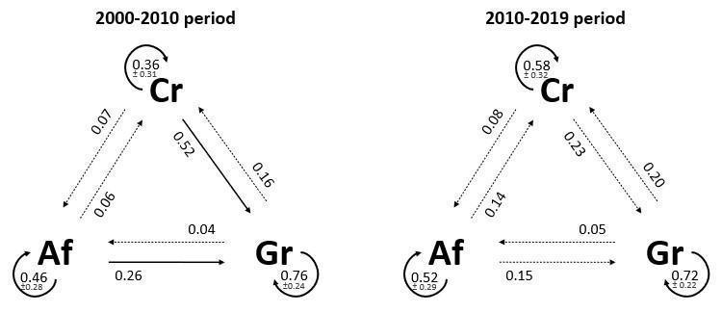
Figure 2: Markov chain models of land-cover change in Uruguay for 2000-2010 and 2010-2019 periods. Numbers and line style indicate the mean and standard deviation persistence/transition probabilities among land-covers. Af: Afforestation; Gr: Grasslands; Cr: Croplands. Dotted line: 0-0.3; solid line: 0.3-0.6 and bold line: 0.6-1.

Grasslands were the most abundant LC class for the Uruguayan territory during the observed (2000, 2010 and 2019) as well as the predicted (2028 and 2037) years. However, projections for croplands and afforestation indicate that their observed trend will continue to increase, reaching 30 and 11 %, respectively, of the Uruguayan territory (Figure 3). The increase in croplands was mainly observed in the north and central regions of Uruguay, while the increase in afforestation was mainly observed in the north-eastern and south-eastern region of the country (Figure 4). Surprisingly, the loss of area for Cr and Af categories was extremely low, both for observed (2010-2019) and projected (2019-2037) trends (Figure 4). The increase in Af and Cr is associated with the decrease in grassland area, which goes from 60% in 2000 to 46% in 2037.
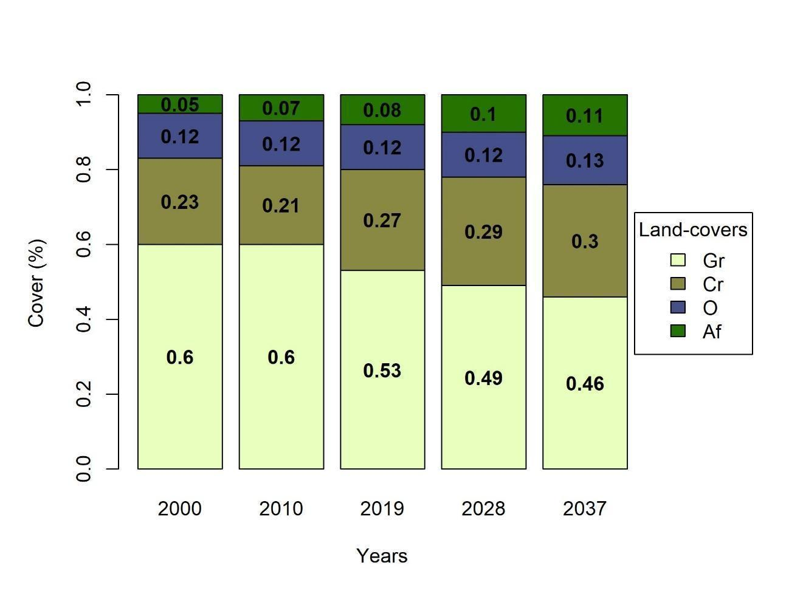
Figure 3: Relative cover (%) of each land-cover for the observed (2000, 2010, and 2019) and predicted years (2028 and 2037). Af: Afforestation; Gr: Grasslands; Cr: Croplands and O: Others.

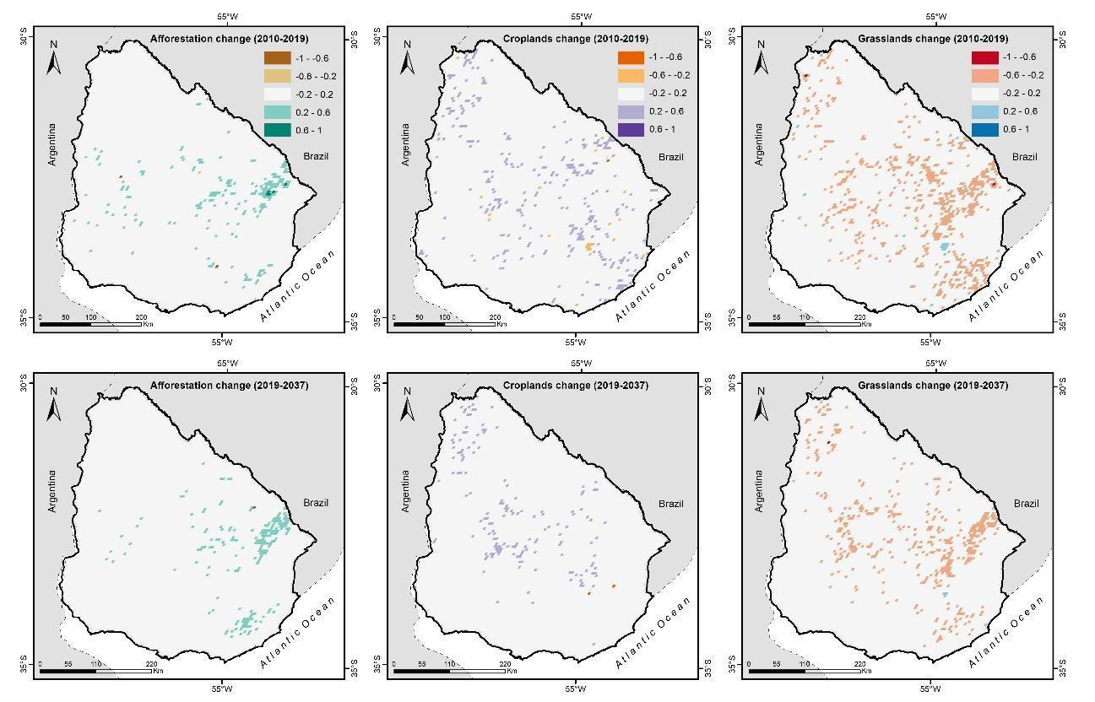
Figure 4: Observed (2010-2019; top) and predicted (2019-2037, down) land-cover changes in Uruguay.

  - Observed and predicted ESSI
The ESSI increases with grasslands and but decreases with croplands. The most parsimonious model was: ESSI = 0.73 + 0.029Gr - 0.0016*Cr. This model explained 75% of the spatial and temporal variability and was statistically significant (p<0.001; Table S1).
The ESSI showed a clear regional pattern with differences that became less pronounced over the study years (Figure 5). In 2000, the index showed large portions of the Uruguayan territory with high ES supply and decreases towards the western and eastern regions. In 2019, the index showed a generalized decrease, particularly in the centre and north-eastern regions, while the western and eastern regions maintained the lowest values. Finally, the projection generated in the ESSI for 2037 shows an even more marked decrease, where only some grids in the north region maintained high values and the western and eastern regions showed the lowest value. Overall, the relative change (excluding water and afforested grids) in the ESSI between 2000 and 2037 shows an average of -5% for Uruguay with a maximum and minimum peak of 60 and -20 % (Figure 5).
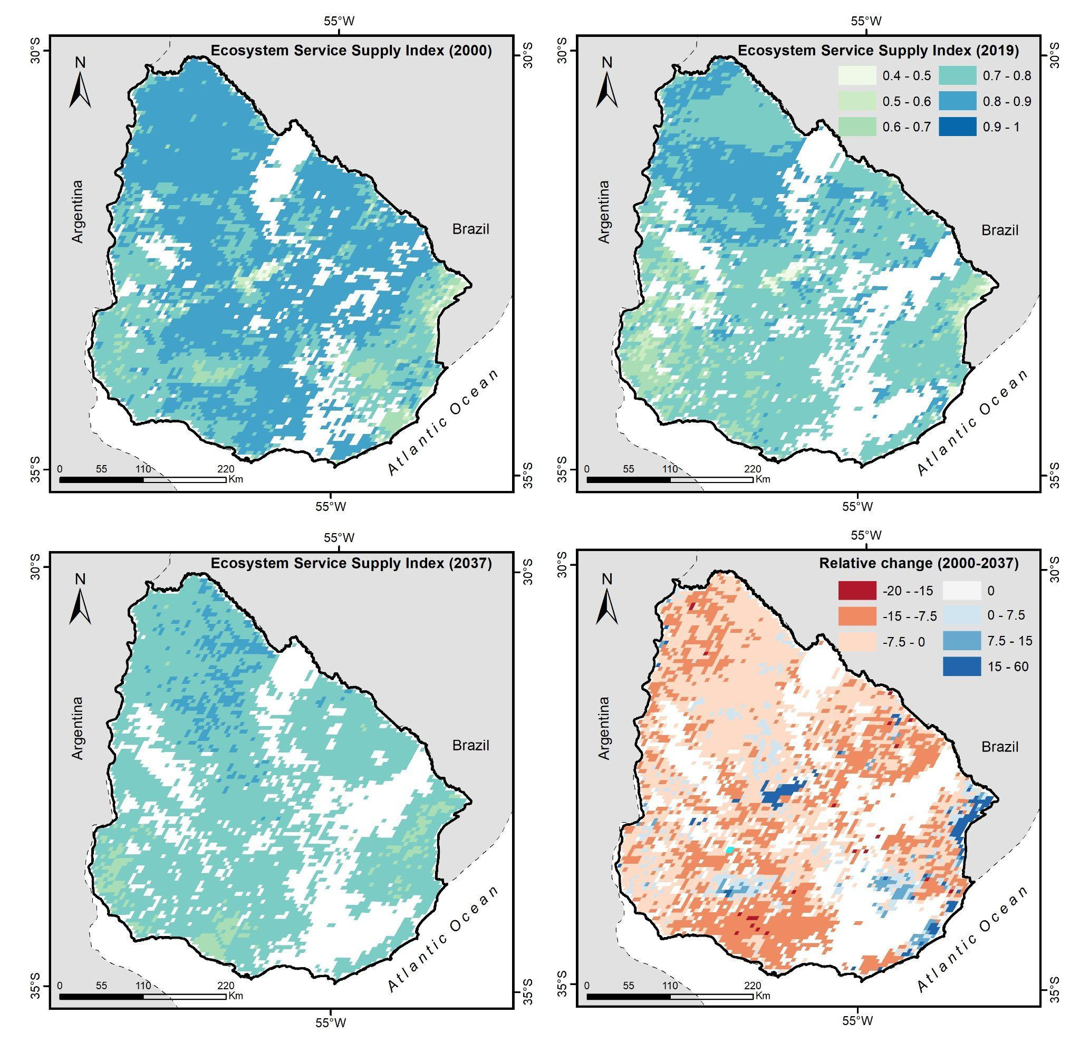
Figure 5: Observed (2000 and 2019), predicted (2037) and relative change (2000-2037) Ecosystem Service Supply Index (ESSI) for non-forested grids (<10%) in Uruguay.

- Discussion

The results of this study indicate that the current trends in LC change would continue in the next decades in Uruguay. As it has been occurring (Baeza and Paruelo, 2020; Baeza et al. 2022), the main transformation will be the replacement of grasslands and shrublands by afforestation and croplands. Despite their simplicity, the Markov chains models proved to be a useful tool for generating projections in land-covers. Furthermore, the availability of high-quality and freely accessible data, such as the LC maps produced by the MapBiomas initiative, as well as the quantification of ES supply through a remote sensing-based approach, represent important advantages for assessing the human impacts on ES supply and for developing sustainable intensification strategies (Paruelo and Sierra, 2022).
The Markov chains reported in this work agree, in general terms, with those described by Vega et al. (2009) for Uruguay. In both works, Markov chains showed, on the one hand, a high probability of grasslands persistence, which decreased over time, and, on the other hand, a high probability of transition for Cr→Gr and Af→Gr, particularly in the first decade of the 21st century. These results highlight the importance of preserving current grasslands areas in Uruguay. It is important to note that, among the countries that constitute the Río de la Plata Grasslands region, Uruguay currently has the highest relative proportion of grasslands (Baeza et al. 2022), which generates, at regional and international level, a unique environmental and productive distinction. However, the lack of public policies and the current commodity prices further threaten the conservation of this ecosystem (Paruelo et al. 2006; Redo et al. 2012; Gorosábel et al. 2020).
There are several assumptions around the Markov chains modelling. Among them, perhaps, the most important is that they assume that the rates of transition and/or permanence between classes is constant over time (Çınlar, 2011). Clearly, the reality of LC changes does not meet this requirement; on the contrary, they are dynamic. Clearly, this is reflected in the differences found between the Markovian models for the two periods analysed (2000-2010 and 2010-2019). LC changes in Uruguay are subject to several factors that vary in both time and space, for example, the price of commodities (mainly soybean, Redo et al. 2012), the introduction of new technologies such as no-tillage or GMOs (Vassallo, 2013; Terradas et al. 2016), the implementation of incentives or regulations through public policies (Gorosábel et al. 2020), among others.
The projections generated in this work show a 7 % reduction in grassland area by 2037. The environmental and social consequences of grassland transformation have highlighted the need to regulate the advance of croplands and afforestation (Paruelo et al. 2006, Staiano et al. 2022). In this context, several initiatives have been implemented in Uruguay with the aim of conserving grasslands. One of them involves the creation, in 2012, of the Board of Livestock on Natural Grasslands (“Mesa de Ganadería sobre Campo Natural”, MGCN for its acronym in Spanish). The primary goals of the MGCN, an inter-institutional public institution, are the conservation of grassland socio-ecological systems (MGAP, 2022). Additionally, in the context of the MGCN, Staiano et al. (2022) characterized and mapped the Conservation Value of Grasslands from a spatially explicit territorial diagnosis based on multiple criteria (ecological and socio-economic) and incorporating explicitly and in quantitative terms the assessments and opinions of the actors involved. This approach provides an important foundation for the development of public policies that are supported by objective evidence.. Brazeiro et al. (2020) also highlight three key issues to generate a balance in the context of accelerated LC change for Uruguay: a) better information for society in general and policy makers in particular, b) greater articulation and integration between national agricultural and environmental policies, and c) integrating the private sector into national conservation policies.
The ES supply, estimated from the ESSI, was negatively determined by cropland cover, and positively related to grassland cover. This relationship is in line with the ESSI calculation, where more stable (low NDVI_{cv}) and productive (high NDVI_{mean}) sites will show a higher ESSI value (Paruelo et al. 2016). The ESSI of grasslands was, on average, 15.2 % higher than the ESSI of croplands and these differences was more pronounced in areas with high levels of agricultural intensification (e.g. 5x5 grids with 100% cover by croplands). These results are consistent with those reported by Paruelo et al. (2022) for the Río de la Plata Grasslands region, where less transformed areas had higher ES supply. Regarding C stocks, an estimate based on ESSI values according to the model proposed by Baldassini et al. (2022), showed a 4.7% reduction (5.12 Mg/ha) in the first 20 cm between 2000-2037 due to grassland substitution. To put this in perspective, this value represents 12.4% of the CO₂ emissions of Uruguay's energy sector by 2021 (SNRCC, 2022). Clearly, grasslands play an important role in supplying key ES to society, particularly provisioning services such as meat, wool, and clean water supply as well as regulating services such as climate and hydrological regulation (Sala and Paruelo, 1997, Zhao et al. 2020).

- Conclusions
This study reports significant changes in land-cover and ecosystem services supply in Uruguay over the observed period (from 2000 to 2019). The highest probability of persistence was found for grasslands, which were also the most abundant land-cover class in the country. Our projections indicate that croplands and afforestation will continue to increase in the coming years at the expense of the area covered by grasslands. Land-cover changes already had a significant impact on the supply of key ecosystem services in the country. The ESSI showed a clear regional pattern and a significant decrease in the supply of ecosystem services across the country over time. The projected changes will result into a further decrease in ES supply. Our estimates indicate a 5% reduction by 2037.
These findings provide an important empirical basis for territorial planning and the sustainable management of natural resources. The world's grasslands are being transformed at alarming rates (Henwood, 1998, Ellis and Ramankutty, 2008, Parr et al. 2014, Carbutt et al. 2017). Under the current scenario of LC change, coupled with the low level of protection of grasslands (Hoekstra et al. 2005, Jones et al. 2018), and the existing information gaps linked to restoration strategies (Dudley et al. 2020, Buisson et al. 2022), puts this ecosystem in an extremely vulnerable situation. Grassland conservation strategies are urgently needed as well as increased visibility of this natural ecosystem (Veldman et al. 2015, Overbeck et al. 2022). Public policies are needed to promote the productive conservation of this ecosystem and to reduce the social and environmental consequences of LC change.

- References
Altesor, A., Gallego, F., Ferrón, M., Pezzani, F., López-Mársico, L., Lezama, F., Baeza, S., Pereira, M., Costa, B., Paruelo, J. M. 2019. Inductive approach to build state-and-transition models for Uruguayan grasslands. Rangeland Ecol. Manage. 72, 1005-1016. https://doi.org/10.1016/j.rama.2019.06.004
Andrade, B. O., Marchesi, E., Burkart, S., Setubal, R. B., Lezama, F., Perelman, S., Schneider, A., Trevisan, R., Overbeck G. E., Boldrini, I. I. 2018. Vascular plant species richness and distribution in the Río de la Plata grasslands. Bot. J. Linn. Soc. 188, 250-256. https://doi.org/10.1093/botlinnean/boy063
Baeza, S., Paruelo, J. M. 2018. Spatial and temporal variation of human appropriation of net primary production in the Rio de la Plata grasslands. ISPRS J. Photogramm. 145, 238-249. https://doi.org/10.1016/j.isprsjprs.2018.07.014
Baeza, S., Paruelo, J. M. 2020. Land use/land cover change (2000–2014) in the Rio de la Plata grasslands: an analysis based on MODIS NDVI time series. Remote Sens. 13, 381. https://doi.org/10.3390/rs12030381
Baeza, S., Vélez-Martin, E., De Abelleyra, D., Banchero, S., Gallego, F., Schirmbeck, J., Verón, S., Vallejos, M., Weber, E., Oyarzabal, M., Barbieri, A., Petek, M., Guerra Lara, M., Sarrailhé, S. S., Balsi, G., Bagnato, C., Bruzzone, L., Ramos, S., Hasenack, H. 2022. Two decades of land cover mapping in the Río de la Plata grassland region: The MapBiomas Pampa initiative. Remote Sens. Appl.: Soc. Environ. 28, 100834. https://doi.org/10.1016/j.rsase.2022.100834
Baldassini, P., Baethgen, W., Sans, G. C., Quincke, A., Pravia, M. V., Terra, J., Macedo, I., Piñeiro, G., Paruelo, J. M. 2022. Carbon stocks and potential sequestration of Uruguayan soils. A road map to a comprehensive characterization of temporal and spatial changes to assess Carbon footprint. Preprint accessed at: https://doi.org/10.31219/osf.io/3buqs
Baldi, G., Paruelo, J. M. 2008. Land-use and land cover dynamics in South American temperate grasslands. Ecol. Soc. 13(2). http://www.ecologyandsociety.org/vol13/iss2/art6/
Balzter, H. 2000. Markov chain models for vegetation dynamics. Ecol. Modell. 126, 139-154. https://doi.org/10.1016/S0304-3800(00)00262-3
Bond, W. J. 2019. Open Ecosystems: ecology and evolution beyond the forest edge. Oxford University Press, NY. 192 pp
Boyd, J., Banzhaf, S. 2007. What are ecosystem services? The need for standardized environmental accounting units. Ecol. Econ. 63, 616-626. https://doi.org/10.1016/j.ecolecon.2007.01.002
Brancalion, P. H., Holl, K. D. 2020. Guidance for successful tree planting initiatives. J. Appl. Ecol. 57, 2349-2361. https://doi.org/10.1111/1365-2664.13725
Brazeiro, A., Achkar, M., Toranza, C., Bartesaghi, L. 2020. Agricultural expansion in Uruguayan grasslands and priority areas for vertebrate and woody plant conservation. Ecol. Soc. 25(1). https://doi.org/10.5751/ES-11360-250115
Buisson, E., Archibald, S., Fidelis, A., Suding, K. N. 2022. Ancient grasslands guide ambitious goals in grassland restoration. Science. 377, 594-598. https://doi.org/10.1126/science.abo4605
Carbutt, C., Henwood, W. D., Gilfedder, L. A. 2017. Global plight of native temperate grasslands: going, going, gone?. Biodivers. Conserv. 26, 2911-2932. https://doi.org/10.1007/s10531-017-1398-5
Caride, C., Piñeiro, G., Paruelo, J. M. 2012. How does agricultural management modify ecosystem services in the argentine Pampas? The effects on soil C dynamics. Agric. Ecosyst. Environ. 154, 23-33. https://doi.org/10.1016/j.agee.2011.05.031
Céspedes-Payret, C., Piñeiro, G., Gutiérrez, O., Panario, D. 2012. Land use change in a temperate grassland soil: afforestation effects on chemical properties and their ecological and mineralogical implications. Sci. Total Environ. 438, 549-557. https://doi.org/10.1016/j.scitotenv.2012.08.075
Çınlar, E. (2011). Markov Processes. In: Probability and Stochastics. Graduate Texts in Mathematics, vol 261. Springer, New York, NY. https://doi.org/10.1007/978-0-387-87859-1_9
Díaz, S., Demissew, S., Carabias, J., Joly, C., Lonsdale, M., Ash, N., Larigauderie, A., Adhikari, J. r., Arico, S., Báldi, A., Bartuska, A., Baste, I. A., Bilgin, A., Brondizio, E., Chan, K., Figueroa, V. E., Duraiappah, A., Fischer, M., Hill, R., Koetz, T., Leadley, P., Lyver, P., Mace, G. M., Martin-Lopez, B., Okumura, M., Pacheco, D., Pascual, U., Pérez, E. S., Reyers, B., Roth, E., Saito, O., Scholes, R. J., Sharma, N., Tallis, H., Thaman, R., Watson, R., Yahara, T., Hamid, Z. A., Akosim, C., Al-Hafedh, Y., Allahverdiyev, R., Amankwah, E., Asah, S. T., Asfaw, Z., Bartus, G., Brooks, L. A., Caillaux, J., Dalle, g., Darnaedi, D., Driver, A., Erpul, G., Escobar-Eyzaguirre, P., Failler, P., Mokhtar-Fouda, A. M., Fu, B., Gundimeda, H., Hashimoto, S., Homer, F., Lavorel, S., Lichtenstein, G., Mala, W. A., Mandivenyi, W., Matczak, P., Mbizvo, C., Mehrdadi, M., Metzger, J. P., Mikissa, J. B., Moller, H., Mooney, H. A., Mumby, P., Nagendra, H., Nesshover, C., Oteng-Yeboah, A. A., Pataki, G., Roué, M., Rubis, J., Schultz, M., Smith, P., Sumaila, R., Takeuchi, K., Thomas, S., Verma, M., Yeo-Chang, Y., Zlatanova, D. 2015. The IPBES Conceptual Framework—connecting nature and people. Curr. Opin. Environ. Sustain. 14, 1-16. http://dx.doi.org/10.1016/j.cosust.2014.11.002
DIEA-MGAP, 2011. Censo General Agropecuario 2011. Dirección de Estadísticas Agropecuarias. Ministerio de Ganadería, Agricultura y Pesca, Uruguay. https://www.gub.uy/ministerio-ganaderia-agricultura-pesca/datos-y-estadisticas/estadisticas/censo-general-agropecuario-2011 (accessed 10 September 2022).
Dixon, A. P., Faber‐Langendoen, D., Josse, C., Morrison, J., Loucks, C. J. 2014. Distribution mapping of world grassland types. J. Biogeogr. 41, 2003-2019. https://doi.org/10.1111/jbi.12381
Dudley, N., Eufemia, L., Fleckenstein, M., Periago, M. E., Petersen, I., Timmers, J. F. (2020). Grasslands and savannahs in the UN Decade on Ecosystem Restoration. Restor. Ecol. 28, 1313-1317. https://doi.org/10.1111/rec.13272
Ellis, E. C., Ramankutty, N. 2008. Putting people in the map: anthropogenic biomes of the world. Front. Ecol. Environ. 6, 439-447. https://doi.org/10.1890/070062
Fisher, B., Turner, R. K., Morling, P. 2009. Defining and classifying ecosystem services for decision making. Ecol. Econ. 68, 643-653. https://doi.org/10.1016/j.ecolecon.2008.09.014
Fox, J., Weisberg, S. 2011. Multivariate linear models in R. An R Companion to Applied Regression. Los Angeles: Thousand Oaks.
Gorelick, N., Hancher, M., Dixon, M., Ilyushchenko, S., Thau, D., Moore, R. 2017. Google Earth Engine: Planetary-scale geospatial analysis for everyone. Remote Sens. Environ. 202, 18-27. https://doi.org/10.1016/j.rse.2017.06.031
Gorosábel, A., Estigarribia, L., Lopes, L. F., Martinez, A. M., Martínez-Lanfranco, J. A., Adenle, A. A., Rivera-Rebella, C., Oyinlola, M. A. 2020. Insights for policy-based conservation strategies for the Rio de la Plata Grasslands through the IPBES framework. Biota Neotrop, 20. https://doi.org/10.1590/1676-0611-BN-2019-0902
Gurka, M. J. 2006. Selecting the best linear mixed model under REML. The American Statistician 60, 19-26. https://doi.org/10.1198/000313006X90396
Gutiérrez, F., Gallego, F., Paruelo, J. M., Rodríguez, C. 2020. Damping and lag effects of precipitation variability across trophic levels in Uruguayan rangelands. Agric. Syst. 185, 102956. https://doi.org/10.1016/j.agsy.2020.102956
Henwood, W. D. 1998. An overview of protected areas in the temperate grasslands biome. Parks 8, 3-8.
Hoekstra, J. M., Boucher, T. M., Ricketts, T. H., Roberts, C. 2005. Confronting a biome crisis: global disparities of habitat loss and protection. Ecol. Lett. 8, 23-29. https://doi.org/10.1111/j.1461-0248.2004.00686.x
INUMET, 2022. Instituto Uruguayo de Meteorología. https://www.inumet.gub.uy/clima/estadisticas-climatologicas/tablas-estadisticas (accessed 10 September 2022).
Jobbágy, E. G., Vasallo, M., Farley, K. A., Piñeiro, G., Garbulsky, M. F., Nosetto, M. D., Jackson, R. B., Paruelo, J. M. 2006. Forestación en pastizales: hacia una visión integral de sus oportunidades y costos ecológicos. Agrociencia Uruguay 10, 109-124. https://doi.org/10.31285/AGRO.10.934
Jones, H. P., Jones, P. C., Barbier, E. B., Blackburn, R. C., Rey Benayas, J. M., Holl, K. D., McCrackin, M., Meli, P., Montoya, D., Mateos, D. M. 2018. Restoration and repair of Earth's damaged ecosystems. Proc. R. Soc. Ser. B Biol. Sci. 285, 20172577. https://doi.org/10.1098/rspb.2017.2577
Lezama, F., Pereira, M., Altesor, A., Paruelo, J. M. 2019. Grasslands of Uruguay: classification based on vegetation plots. Phytocoenologia 49, 211-229. https://doi.org/10.1127/phyto/2019/0215
MapBiomas, 2022. MapBiomas Pampa Trinacional Iniciative. https://pampa.mapbiomas.org/ (accessed 15 April 2022).
MGAP, 2022. Mesa de ganadería sobre campo natural. Ministerio de Ganadería, Agricultura y Pesca. Available at: https://www.gub.uy/ministerio-ganaderiaagricultura-pesca/politicas-y-gestion/mesa-ganaderia-sobre-campo-natural (Accessed October 21, 2021).
Modernel, P., Rossing, W. A., Corbeels, M., Dogliotti, S., Picasso, V., Tittonell, P. 2016. Land use change and ecosystem service provision in Pampas and Campos grasslands of southern South America. Environ. Res. Lett. 11, 113002. https://doi.org/10.1088/1748-9326/11/11/113002
Nagelkerke, N. J. 1991. A note on a general definition of the coefficient of determination. Biometrika. 78, 691-692. https://www.jstor.org/stable/2337038
Nosetto, M. D., Jobbágy, E. G., Paruelo, J. M. 2005. Land‐use change and water losses: the case of grassland afforestation across a soil textural gradient in central Argentina. Global Change Biol. 11, 1101-1117. https://doi.org/10.1111/j.1365-2486.2005.00975.x
Overbeck, G. E., Vélez-Martin, E., da Silva Menezes, L., Anand, M., Baeza, S., Carlucci, M. B., Dechoum, M. S., Durigan, G., Fidelis, A., Guido, A., Moro, M. F., Rodrigues Munhoz, C. B., Reginato, M., Schütz Rodrigues, R., Rosenfield, M. F., Sampaio, A. B., Barbosa da Silva, F. H., Silveira, F. A., Sosinski Jr, E. E., Staude, I. R., Temperton, V. M., Turchetto, C., Veldman, J. W., Viana, P. L., Zappi, D. C., Müller, S. C. 2022. Placing Brazil's grasslands and savannas on the map of science and conservation. Perspect. Plant Ecol. Evol. Syst. 56, 125687. https://doi.org/10.1016/j.ppees.2022.125687
Oyarzabal, M., Andrade, B., Pillar, V. D., Paruelo, J. M. 2020. Temperate Subhumid Grasslands of Southern South America, In: Goldstein, M. I., Della Sala, D. A. (Eds.), Encyclopaedia of the World's Biomes, Elsevier, pp. 577-593. https://doi.org/10.1016/B978-0-12-409548-9.12132-3
Parr, C. L., Lehmann, C. E., Bond, W. J., Hoffmann, W. A., Andersen, A. N. 2014. Tropical grassy biomes: misunderstood, neglected, and under threat. Trends Ecol. Evol. 29, 205-213. https://doi.org/10.1016/j.tree.2014.02.004
Paruelo, J. M., Guerschman, J. P., Piñeiro, G., Jobbagy, E. G., Verón, S. R., Baldi, G., Baeza, S. 2006. Cambios en el uso de la tierra en Argentina y Uruguay: marcos conceptuales para su análisis. Agrociencia Uruguay 10, 47-61. https://doi.org/10.31285/AGRO.10.929
Paruelo, J. M., Jobbágy, E. G., Oesterheld, M., Golluscio, R. A., Aguiar, M. R. 2007. The grasslands and steppes of Patagonia and the Rio de la Plata plains, in: Veblen, T. T., Young, K. R., Orme A. R. (Eds.). The physical geography of South America, pp. 232-248.
Paruelo, J. M. 2008. La caracterización funcional de ecosistemas mediante sensores remotos. Ecosistemas 17(3). https://www.revistaecosistemas.net/index.php/ecosistemas/article/view/83
Paruelo, J. M., Texeira, M., Staiano, L., Mastrángelo, M., Amdan, L., Gallego, F. 2016. An integrative index of Ecosystem Services provision based on remotely sensed data. Ecol. Indic. 71, 145-154. https://doi.org/10.1016/j.ecolind.2016.06.054
Paruelo, J. M., Guerschman, J. P., Baeza, S., Trinco, F. D. 2019. ¿Cómo se reparten las ganancias de carbono? Apropiación Humana de la Productividad Primaria, in: Laterra, P., Paruelo, J. M. (Eds.). El lugar de la naturaleza en la toma de decisiones. Servicios ecosistémicos y ordenamiento territorial rural. Ediciones Ciccus, Buenos Aires, Argentina, pp. 177-195.
Paruelo, J. M., Sierra, M. 2022. Sustainable intensification and ecosystem services: how to connect them in agricultural systems of southern South America. J. Environ. Sci. Stud. 1-9. https://doi.org/10.1007/s13412-022-00791-9
Paruelo, J. M., Oesterheld, M., Altesor, A., Piñeiro, G., Rodríguez, C., Baldassini, P., Irisarri, G., López-Mársico, L., Pillar, V. D. 2022. Grazers and fires: Their role in shaping the structure and functioning of the Río de la Plata Grasslands. Ecología Austral. 32, 784-805. https://doi.org/10.25260/EA.22.32.2.1.1880
Redo, D. J., Aide, T. M., Clark, M. L., Andrade-Núñez, M. J. 2012. Impacts of internal and external policies on land change in Uruguay, 2001–2009. Environ. Conserv. 39, 122-131. https://doi.org/10.1017/S0376892911000658
Ríos, C., Lezama, F., Rama, G., Baldi, G., Baeza, S. 2022. Natural grassland remnants in dynamic agricultural landscapes: identifying drivers of fragmentation. Perspect. Ecol. Conserv. 20, 205-215. https://doi.org/10.1016/j.pecon.2022.04.003
Roy, D. P., Borak, J. S., Devadiga, S., Wolfe, R. E., Zheng, M., Descloitres, J. 2002. The MODIS land product quality assessment approach. Remote Sens. Environ. 83, 62-76. https://doi.org/10.1016/S0034-4257(02)00087-1
Sala, O. E., Paruelo, J. M. 1997. Ecosystem services in grasslands. Nature’s services: Societal dependence on natural ecosystems. P.237-251.
Silveira, L., Gamazo, P., Alonso, J., Martínez, L. 2016. Effects of afforestation on groundwater recharge and water budgets in the western region of Uruguay. Hydrol. Processes. 30, 3596-3608. https://doi.org/10.1002/hyp.10952
SNRCC, 2022. Sistema Nacional de Respuesta al Cambio Climático, Ministerio de Ambiente. Link (accessed 20 October 2022).
Soriano, A., León, R. J. C., Sala, E. O., Lavado, R. S., Dereguibus, V. A., Cahuepé, M. A., Scaglia, O. A., Velázquez, C. A., Lemcoff, J. H. 1991. Rio de la Plata Grasslands, in: Coupland (ed.) Ecosystems of the world 8A. Natural grasslands. Introduction and Western Hemisphere. 1st edn, New York. Elsevier. pp 367-407.
Staiano, L., Sans, G. H. C., Baldassini, P., Gallego, F., Texeira, M. A., Paruelo, J. M. 2021. Putting the Ecosystem Services idea at work: Applications on impact assessment and territorial planning. Environ. Dev. 38, 100570. https://doi.org/10.1016/j.envdev.2020.100570
Staiano, L., Gallego, F., Altesor, A., Paruelo, J. M. 2022. Where and why to conserve grasslands socio-ecosystems? A spatially explicit participative approach. Front. Environ. Sci. 10. https://doi.org/10.3389/fenvs.2022.820449
Stanturf, J. A., Kleine, M., Mansourian, S., Parrotta, J., Madsen, P., Kant, P., Burns, J., Bolte, A. 2019. Implementing forest landscape restoration under the Bonn Challenge: A systematic approach. Ann. For. Sci. 76, 1-21. https://doi.org/10.1007/s13595-019-0833-z
Terradas-Cobas, L., Céspedes-Payret, C., Calabuig, E. L. 2016. Expansion of GM crops, antagonisms between MERCOSUR and the EU. The role of R&D and intellectual property rights’ policy. Environ. Dev. 19, 49-58. https://doi.org/10.1016/j.envdev.2016.06.003
Texeira, M., Oyarzabal, M., Pineiro, G., Baeza, S., Paruelo, J. M. 2015. Land cover and precipitation controls over long‐term trends in carbon gains in the grassland biome of South America. Ecosphere 6, 1-21. https://doi.org/10.1890/ES15-00085.1
Tiscornia, G., Jaurena, M., Baethgen, W. 2019. Drivers, process, and consequences of native grassland degradation: Insights from a literature review and a survey in Río de la Plata grasslands. Agronomy 9, 239. https://doi.org/10.3390/agronomy9050239
Vassallo, M. 2013. Dinámica y competencia intrasectorial en la agricultura uruguaya: Los cambios en la última década. Agrociencia Uruguay 17, 170-179.
Vassallo, M. M., Dieguez, H. D., Garbulsky, M. F., Jobbágy, E. G., Paruelo, J. M. 2013. Grassland afforestation impact on primary productivity: a remote sensing approach. Appl. Veg. Sci. 16, 390-403. https://doi.org/10.1111/avsc.12016
Vega, E., Baldi, G., Jobbágy, E. G., Paruelo, J. 2009. Land use change patterns in the Río de la Plata grasslands: the influence of phytogeographic and political boundaries. Agric. Ecosyst. Environ. 134, 287-292. https://doi.org/10.1016/j.agee.2009.07.011
Veldman, J. W., Overbeck, G., Negreiros, D., Mahy, G., Le Stradic, S., Fernandes, G. W., Duringan, G., Buisson, E., Putz, F. E., Bond, W. J. 2015. Tyranny of Trees in Grassy Biomes. Science 347, 484-485 https://doi.org/10.1126/science.347.6221.484-c
Volante, J., Mosciaro, J., Morales Poclava, M., Vale, L., Castrillo, S., Sawchik, J., Tiscornia, G., Fuente, M., Maldonado, I., Vega, A., Trujillo, R., Cortéz, L., Paruelo, J. 2015. Expansión agrícola en Argentina, Bolivia, Paraguay, Uruguay y Chile entre 2000-2010: Caracterización espacial mediante series temporales de índices de vegetación. RIA. Revista de investigaciones agropecuarias 41, 179-191.
White, R. P., Murray, S., Rohweder, M., Prince, S. D., Thompson, K. M. 2000. Grassland ecosystems. Washington, DC, USA: World Resources Institute.
Zhao, Y., Liu, Z., Wu, J. 2020. Grassland ecosystem services: a systematic review of research advances and future directions. Landscape Ecol. 35, 793-814. https://doi.org/10.1007/s10980-020-00980-3
Zuur, A. F., Ieno, E. N., Walker, N. J., Saveliev, A. A., Smith, G. M. 2009. Mixed effects models and extensions in ecology with R (Vol. 574). New York: Springer. https://doi.org/10.1007/978-0-387-87458-6

