Río de la Plata Grasslands: how did land-cover and ecosystem functioning change in the 21st century?
Gallego F.¹, Bagnato C.², Baeza S.³ Camba-Sans G⁴. and Paruelo J.M.^{1,4,5}

¹ Instituto de Ecología y Ciencias Ambientales, Facultad de Ciencias, Universidad de la República. Iguá 4225, Montevideo, Uruguay.
² Laboratorio de Análisis Regional y Teledetección. Facultad de Agronomía- Universidad de Buenos Aires- IFEVA- CONICET. Av. San Martín 4453- C1417DSE, Buenos Aires, Argentina
³ Departamento de Sistemas Ambientales, Facultad de Agronomía, Universidad de la República. Av. Garzón 780, Montevideo, Uruguay.
⁴Departamento de Métodos Cuantitativos y Sistemas de Información. Universidad de Buenos Aires. Facultad de Agronomía. Buenos Aires, Argentina
⁵ Instituto Nacional de Investigación Agropecuaria (INIA), Estación Experimental La Estanzuela, Ruta 50 km 11, Colonia, Uruguay

Abstract
The Río de la Plata Grasslands region is one of the largest plains in the world, covering a significant portion of the southern Brazilian grasslands. This temperate sub-humid region is also one of the most diverse grassland areas globally. However, in the last decades, important land-use and land-cover changes occurred threatening the natural ecosystem and the provision of essential ecosystem services. In this chapter, we provide an overview of the primary land-use and land-cover changes that have occurred in this region over the last two decades. We also discuss some of the consequences derived from these changes on the ecosystem functioning, the supply of ecosystem services, and the human appropriation of primary production. Finally, we evaluate the observed transition trends among land-use and land-covers and speculate on the most likely changes that may occur in the next few years.

Introduction
South Brazilian grasslands are part of a wider ecoregion that extends throughout Uruguay and central western Argentina known as the Río de la Plata Grasslands (RPG) (Soriano et al. 1991). The RPG occupy the large plain formed around the estuary of the Río de la Plata, from 28 to 38° South latitude and from 50 to 66.5° West longitude, covering approximately 760.000 km². The average annual temperature varies from 13 °C in the South to 20 °C in the North, and average annual rainfall increases from 400 mm.year⁻¹ in the Southwest up to 1500 mm.year⁻¹ in the Northeast (Oyarzabal et al. 2020). Grasslands, formed by a combination of C3 and C4 grasses and a broad set of herbs, are the dominant vegetation (Perelman et al. 2001; Overbeck et al. 2007; Lezama et al. 2019; Andrade et al. 2019). The RPG has been divided in 8 sub-regions based on their geomorphology, soils, drainage and their link with natural vegetation and land-use. These sub-regions are the Rolling Pampa, the Inland Pampa (itself with two divisions, Flat and West), the Austral Pampa, the Flooding Pampa, the Mesopotamic Pampa, the Southern Campos, and the Northern Campos (Soriano et al. 1991). The Northern Campos sub-region encompasses the Pampa biome in the south Brazilian grasslands.

In recent decades, the areas occupied by grasslands have been extensively replaced by annual crops, sown pastures, and tree plantations (Cordeiro & Hasenack 2009; Graesser et al. 2015; Volante et al. 2015; Baeza & Paruelo, 2018, 2020; Souza et al. 2020; Baeza et al. 2022). These land-use and land-cover changes occurs in a geographical (the RPG) and ecological (temperate and subtropical grasslands) region that have very low levels of protection and hence high risks of species biodiversity erosion (Hoekstra et al. 2005; Watson et al. 2016).

Land-use and land-cover changes represent a major alteration of the surface structure (Foley et al. 2005; Ellis et al. 2010; IPBES, 2019). Changes generally involve the replacement of the dominant plant functional types, a mix of C3 and C4 perennial grasses, by perennial trees or annual plants (either dicots or grasses). However, the replacement of grasslands, shrublands and savannas by annual crops and tree plantations not only reduces biodiversity in terms of composition, it also generates an erosion of the structural and functional diversity (sensu Noss, 1990; Fig. 1). Such structural and functional dimensions of biodiversity, particularly at the ecosystem and landscape level, are often a neglected aspect of global land-use and land-cover transformations. Alcaraz-Segura et al. (2013) showed the consequences of such changes on the regional climate in the southern part of South America.
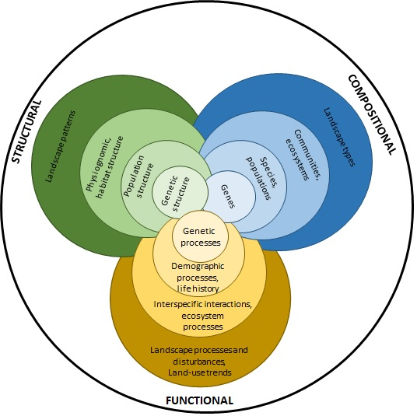
Fig 1. The schematic definition of biodiversity from Noss (1990).

Paruelo et al. (2001) and Alcaraz-Segura et al. (2006) introduced the idea of Ecosystem Functional Types (EFT) as an entity able to be used to describe functional diversity at the landscape level using a common protocol and over large areas. EFT were defined as patches of the earth's surface with similar exchange of matter and energy between biota and the physical environment. Alcaraz-Segura et al. (2013) studied the environmental controls of EFT diversity over the whole Río de la Plata basin. As observed for species richness in the southern hemisphere, water availability, not energy, emerged as the main climatic driver of EFT richness in natural areas of temperate South America. In anthropogenic areas, the roles of both water and energy decrease. Richness increases at low levels of human influence, but as human intervention intensifies, biodiversity decreases.

Functional and structural changes would impact on the environmental performance of the landscape (Forman, 1995; Wu, 2006). Basically, the key question is how the sustainability change in time and space (Paruelo & Sierra, 2022). An operational definition of sustainability should focus more on the changes than on the absolute value. For example, Wu (2013) defines sustainability as the ability to consistently provide specific Ecosystem Services (ES) for the maintenance and improvement of human well-being over the long term.

Many ecological indicators to describe ES supply has been proposed (Burkhard et al. 2012; Paruelo et al. 2016; Englund et al. 2017). Such indicators must be sensitive to critical functional changes (i.e. water or C dynamics, energy surface changes), have to be monitored using a common protocol at low cost and should be auditable by third parties. Land-use and land-cover transformation has obvious structural consequences: the replacement and often the homogenization of the landscape. Three indicators may provide a temporal and spatial perspective of the of the human impact of natural habitat transformation: the diversity of EFT at the landscape level (Alcaraz-Segura et al. 2013), the Ecosystem Service Supply Index (ESSI, Paruelo et al. 2016), and the Human Appropriation of Net Primary Production (HANPP, Baeza & Paruelo, 2018). The first index focus on changes on functional biodiversity and the latest two are based on the effects of human interventions on carbon (C) dynamics. The Uruguayan government included in 2022 these three indicators in the set to describe the environmental footprint of livestock production (Ministerio de Ambiente, 2022).

In this chapter, we described the main structural and functional changes that took place in the Río de la Plata Grasslands in the last two decades focusing on the main land-use and land-cover transitions and the distribution of the Ecosystem Functional Types (EFT). We also analysed some of the consequences derived from land-use and land-cover changes on the diversity of EFT at the landscape level, the supply of ecosystem services and the human appropriation of net primary production. Finally, we speculated on the most likely changes that may occur in the next few years.

OBSERVED CHANGES

Structural changes
The RPG experienced significant landscape transformations over the last two decades (Baldi & Paruelo, 2008; Volante et al. 2015; Baeza & Paruelo 2018, 2020). The results of the mapping initiative carried out by the MapBiomas Pampa project (Collection 1; https://pampa.mapbiomas.org/es; Baeza et al. 2022) show that the region had a net loss of native vegetation (woodlands, grasslands, and wetlands) of 84,701 km² (16.3%) between 2000 and 2019. Particularly, the area occupied by grassland decreased from 36.8 to 29.6% (from 369,647 km² to 297,795 km²; a relative change of -19.4%) and the area under cropland and afforestation increased from 42.5 to 49.9% (from 427,239 km² to 501,489 km²; a relative change of +17.4%) and 1.4 to 2.3% (from 13,867 km² to 23,328 km²; a relative change of +68.2%), respectively (Fig. 2). At the country level, Brazil had the greatest proportional loss of grasslands, with 22,967 km² (-27.6%), mainly due to the expansion of croplands. Argentina had a grassland loss of 36,571 km2 (-20.1%), while in Uruguay the reduction was 12,229 km2 (-11.7%). In the case of Argentina and Uruguay, the reduction of grasslands area was mainly associated with the expansion of croplands and sowed pastures. In the Uruguayan Campos, there was an important increase of tree plantations determining an additional reduction of grasslands area.

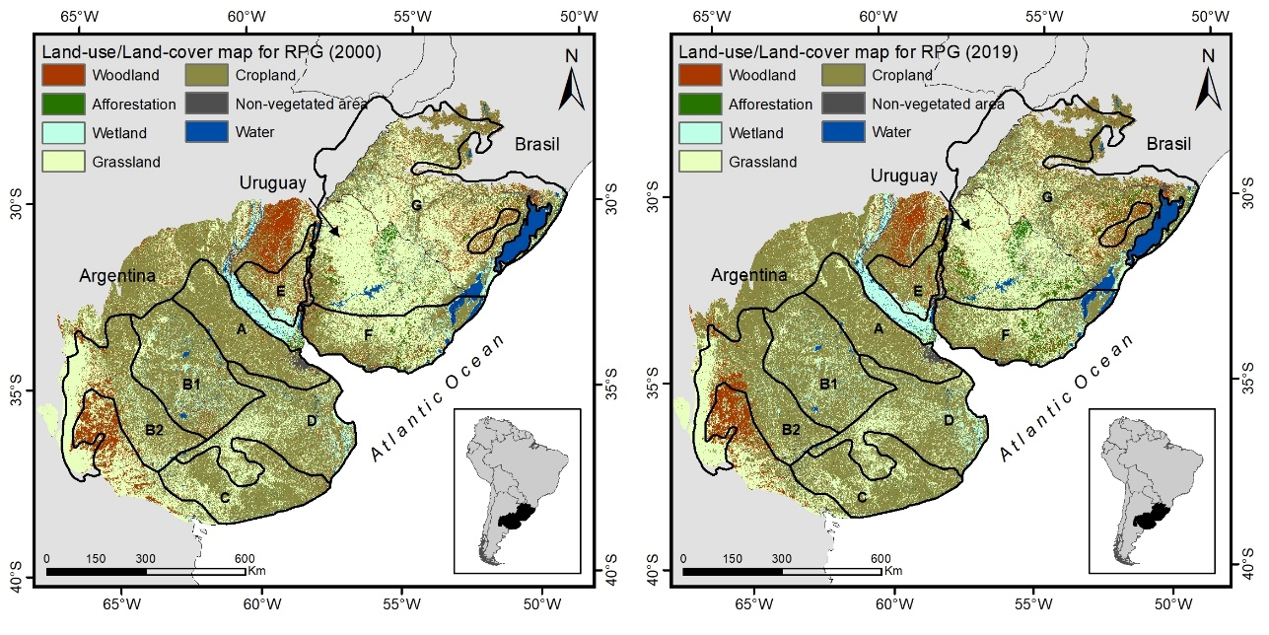
Fig 2. Land-use and land-cover map for the Río de la Plata Grasslands region in 2000 (left) and 2019 (right). Letters denotes different sub-regions of Río de la Plata Grasslands: (A) Rolling Pampa. (B1) Flat Inland Pampa, (B2) West Inland Pampa, (C) Austral Pampa, (D) Flooding Pampa, (E) Mesopotamic Pampa, (F) Southern Campos, (G) Northern Campos. Data from MapBiomas Pampa Initiative Collection1 (https://pampa.mapbiomas.org/es).

All RPG sub-regions, except for the Rolling Pampa (where changes occurred before the analysed period), showed important losses of grasslands between the 2000-2019 period. The highest grasslands losses occurred in the Northern Campos and the West Inland Pampa, with a reduction of 27,894 km² (a relative change of -18.2%) and 11,261 km² (a relative change of -28.2%), respectively. In both cases, losses were associated with the expansion of cropland areas, except for the Northern Campos where afforestation also explained the grassland area reduction. The Flooding Pampa and the Flat Inland Pampa showed the lowest reduction in grasslands area, 2,086 km² (a relative change of -7.8%) and 722 km² (a relative change of -4.7 %), respectively.

Functional changes
To characterize and identify changes in the ecosystem functioning associated to land-use and land-cover changes we mapped the Ecosystem Functional Types (EFT (Paruelo et al. 2001; Alcaraz-Segura et al. 2006). The identification of the EFT was based on the seasonal dynamics of the Normalized Difference Vegetation Index (NDVI). The NDVI is one of the most widely used vegetation indexes and shows a positive relationship with the fraction of photosynthetically active radiation absorbed by green vegetation and hence with productivity of the ecosystems (Pettorelli, 2013). We used NDVI images from the MODIS sensor (collection 6, Mod13q1). These images have a 250-meter spatial resolution (~6 ha) and 16–day temporal resolution.

EFT were defined through remote sensing techniques and using 3 “phenometrics” that synthetize the functional behaviour of ecosystems (Alcaraz-Segura et al. 2013): the mean (NDVI_{MEAN}), the coefficient of variation (NDVI_{CV}) and the date of maximum (NDVI_{fMAX}) (see Fig. S1 in the Supplementary Material). The range of values of each metric was divided into four intervals, giving a potential number of 64 EFT. In the case of the date of maximum, the intervals corresponded to the four seasons of the year. For the mean and coefficient of variation, we calculated the quartiles of the histograms to define the limits of the four classes. We assigned codes to each EFT as suggested by Paruelo et al. (2001) using two letters and a number (three characters). The first letter of the code (Capital) corresponds to increasing the NDVI_{MEAN} (from “A” to “D”). The second letter (lower case) indicate decreasing values of the seasonality (NDVI_{CV}) (from “a” to “d”). Numbers indicate the season in which the maximum value occurs (1 for spring, 2 for summer, 3 for autumn, and 4 for winter). This definition and coding of EFT based solely on descriptors of ecosystem functioning allows for an ecological interpretation of the legend. For example, Aa1 corresponds to an EFT with low radiation interception (productivity), high seasonality, and a maximum peak of photosynthetic activity during the spring. EFT were generated for three periods: 2000, 2010, and 2021. To avoid the effects of specific climatic conditions, EFT were generated for a four-year average: 2000-2003, 2009-2012, and 2018-2021. To make the three assessed periods comparable we used the quartiles calculated for 2000-2003 period to build EFT for each period. Thus, we can compare and characterize the shifts among EFT between periods.

The EFT maps provide a synthetic characterization of spatial patterns of ecosystem functioning and their changes between periods in the RPG (Fig. 3). The 64 possible combinations of the three functional attributes used to build EFT were identified in RPG. The Table 1 provides an interpretation of most abundant EFTs for RPG that together account for almost 70 % of the total area. Despite the period considered, the most abundant EFT was Aa2, a low radiation interception, high seasonality, and a summer peak ecosystem. This EFT is related with agricultural areas mainly in the Rolling and Inland Pampas. The EFT mainly linked to grassland ecosystems were Dd2, Cd1, and Cd3 (Fig. 3 and Table 1). In all cases, these EFT were mainly located in the Southern and Northern Campos and were characterized by a high radiation interception, low seasonality, and a spring/summer/autumn peak ecosystem.

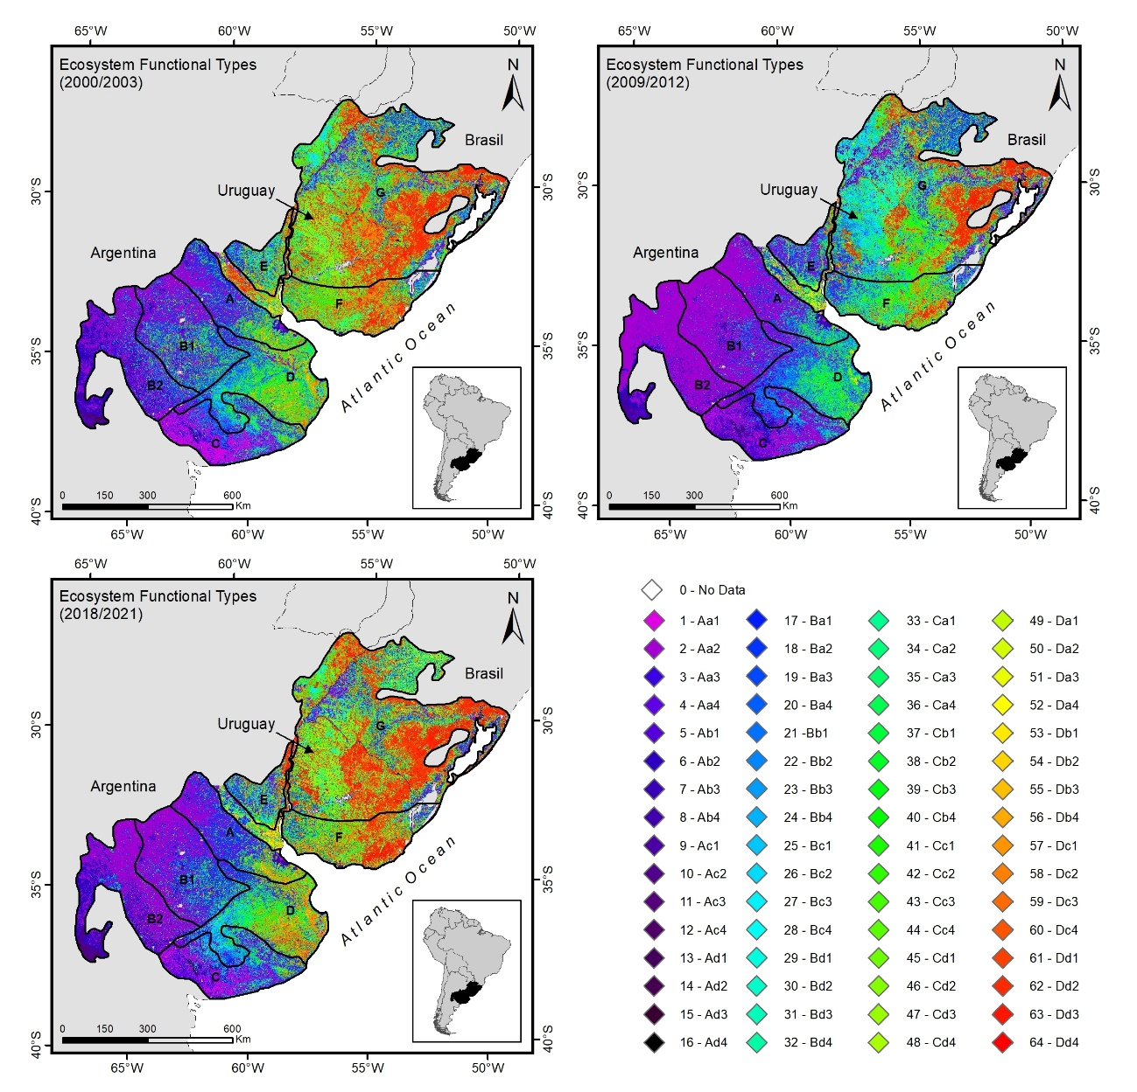
Fig. 3: Ecosystem Functional Types for the Río de la Plata Grasslands region in the three study periods (2000-2003, 2009-2012, and 2018-2021). Letters denotes different sub-regions of Río de la Plata Grasslands: (A) Rolling Pampa. (B1) Flat Inland Pampa, (B2) West Inland Pampa, (C) Austral Pampa, (D) Flooding Pampa, (E) Mesopotamic Pampa, (F) Southern Campos, (G) Northern Campos.

Table 1: Description of most abundant EFT in the Río de la Plata Grassland region for the 2018-2021 period.

EFT | Area [Mha] | EFT interpretation | Geographic Distribution and land-use and land-cover correspondence
Aa2 | 13.82 | Low radiation interception, High seasonality, and summer peak | Mostly agriculture in Rolling and Inland Pampas
Ba2 | 7.20 | Lower Intermediate radiation interception, High seasonality, and summer peak | Agriculture distributed in all RPG
Dd1 | 5.32 | High radiation interception, Low seasonality, and spring peak | Mostly natural vegetation but also include afforestation in Southern and Northern Campos
Dd3 | 4.19 | High radiation interception, Low seasonality, and autumn peak
Dd2 | 4.11 | High radiation interception, Low seasonality, and summer peak
Bb2 | 3.34 | Lower Intermediate radiation interception, upper Intermediate seasonality, and summer peak | Transformed ecosystems evenly distributed in all RPG
Ab2 | 2.73 | Low radiation interception, Upper Intermediate seasonality, and summer peak | Seminatural grasslands ecosystems located in the West Inland Pampa. Small patches of herbaceous vegetation distributed in Argentinian portion of RPG
Dc1 | 2.45 | High radiation interception, Low seasonality, and spring peak | Seminatural wetlands in Flooding and Rolling Pampas and riparian forest in Mesopotamic, Southern and Northern Campos
Cd1 | 2.26 | Upper Intermediate radiation interception, low seasonality, and spring peak | Mainly natural grasslands in Uruguay and Brazil
Cb2 | 2.24 | Upper Intermediate radiation interception, upper intermediate seasonality, and summer peak | Small patches distributed in all regions of RPG mainly associated with natural vegetations as dry seasonal forest, wetland vegetation and some transformed areas
Ca2 | 2.21 | Upper Intermediate radiation interception, high seasonality, and summer peak | Mainly agricultural ecosystems in Northern Campos
Cd3 | 2.16 | Upper Intermediate radiation interception, low seasonality, and autumn peak | Grassland ecosystems in Southern and Northern Campos
Cc2 | 2.04 | Upper Intermediate radiation interception, lower intermediate seasonality, and summer peak | Small patches of transformed and seminatural vegetation distributed in central and northern RPG
Cc1 | 2.03 | Upper Intermediate radiation interception, lower intermediate seasonality, and spring peak | Herbaceous vegetations mainly in Flooding Pampa and Southern Campos
Dc2 | 1.90 | High radiation interception, lower intermediate seasonality, and summer peak | Riparian forest and humid herbaceous vegetations mainly in Northern Campos
The highest NDVI_{MEAN} were found in Northern Campos generally associated with afforestation and some woodlands relicts (Fig. S1 in the Supplementary material). The lowest values of NDVI_{MEAN} presented an even distribution among the whole study area associated with bare soil due to seasonal water bodies and dunes next to the coastlines. High seasonality ecosystems were related to agricultural foci mainly in the West, Inland and Rolling Pampas in Argentina and in the very north of Northern Campos in Brazil. Flooding Pampa and most of Uruguayan natural grassland (Southern and Northern Campos sub-regions) presented the lowest seasonality, including the lands converted to evergreen tree plantations. Most of the EFTs identified showed an NDVI_{fMAX} in summer covering 388,000 km² in 2000-2003, 496,00 km² in 2009-2012 and 312,000 km² in 2018-2021. The phenological indicator of growing season NDVI_{fMAX} showed that most ecosystems of RPG have a summer peak. This is particularly clear in the most transformed areas where conversion to agriculture determine high seasonality as well. Nevertheless, autumn and spring peaks ecosystems can be found across large areas of central RPG, mostly in Uruguay and Flooding and Austral Pampas in Argentina. Areas with winter peak are rare but can be found in specific spots located in the Northern Campos and Mesopotamic Pampas (see Fig. S1 in the Supplementary material).

CONSEQUENCES OF THE STRUCTURAL AND FUNCTIONAL CHANGES

Functional diversity at the landscape level
Functional Diversity was assessed for each analysed period using the Shannon-Wiener Diversity Index (Fig. 4). We defined a 10 x 10 kilometres grid and we calculated the diversity of EFTs for each cell using “landscapemetrics” R package (Hesselbarth et al. 2019). Changes in functional diversity were calculated as the percentage of change between 2000-2003 and 2018-2021 periods (Fig. 4).

EFT diversity presented a heterogeneous pattern with low functional diversity values in the south-west driest portion of RPG and high diversity zones interspersed across all the sub-regions. The maximum values of functional diversity were found in transitional sub-regions characterized for having both natural vegetation’s relicts and transformed areas such as the Flooding Pampas and Southern Campos. The lower diversity areas seem to be associated with very transformed and homogenized agricultural areas of the Inland and Rolling Pampas. Indeed, the functional diversity diminished greatly in the Rolling and Inland Pampas during the last 20 years. In the Southern and Northern Campos, functional diversity generally increased. Flooding and Austral Pampas in Argentina showed greater values of Shannon-Wiener Diversity Index in 2018-2021 than in 2000-2003 period.

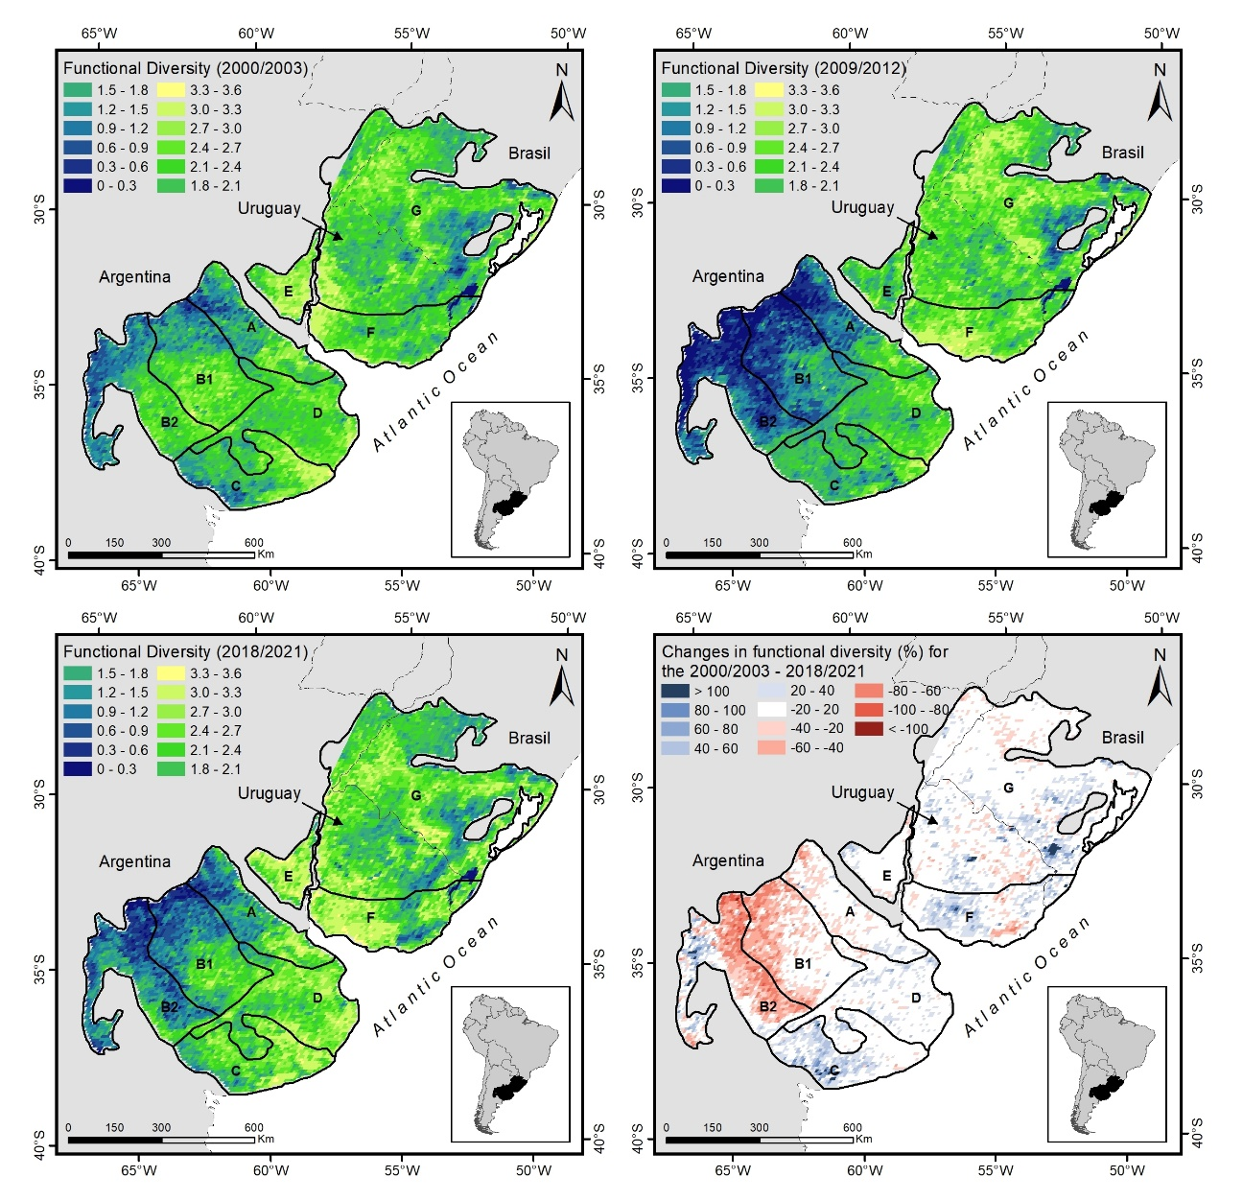
Fig. 4: Functional Diversity for the Río de la Plata Grasslands region represented by the Shannon-Wiener Diversity Index in the three study periods (2000-2003, 2009-2012, and 2018-2021); and Changes in Functional Diversity expressed as the percentage of change in the Shannon-Wiener Diversity Index between 2000-2003 and 2018-2021 periods. Letters denotes different sub-regions of Río de la Plata Grasslands: (A) Rolling Pampa. (B1) Flat Inland Pampa, (B2) West Inland Pampa, (C) Austral Pampa, (D) Flooding Pampa, (E) Mesopotamic Pampa, (F) Southern Campos, (G) Northern Campos.

Ecosystem Service supply

Paruelo et al. (2016) presented a synoptic indicator of “bundles” supporting and regulating ES related to C dynamics, the “Ecosystem Services Supply Index” (ESSI). It is based on vegetation indices derived from remote sensing data, which constitute robust estimators of Net Primary Productivity (NPP) (Monteith, 1972; Piñeiro et al. 2006), an integrating variable of ecosystem functioning (McNaughton et al. 1989). The ESSI merges two attributes of the NDVI annual dynamics: the annual average (NDVI_{MEAN}, a proxy of total C gains) and the intra-annual coefficient of variation (NDVI_{CV}, an indicator of seasonality): ESSI = NDVI_{MEAN} * (1 - NDVI_{CV}). Those sites where annual productivity is higher and more seasonally stable would have a higher ES supply.

The foundation of the ESSI is based on both the conceptual framework of the ES cascade model and the ES bundles concept (Raudsepp-Hearne et al. 2010). According to this scheme, the ESSI represents an integrative index of ecosystem functioning which gives rise to the cascade. It can describe the variation in different regulating and supporting ES (some of them intermediate and others final ES) that vary together in the same direction (ES bundles). The support for using ESSI as a proxy of ES supply was originally based on its positive relationship with four ES estimated from empirical data or mechanistic models: groundwater recharge and avian richness in Dry Chaco forests and soil organic carbon (SOC) in the RPG (Paruelo et al. 2016). Two additional studies provided additional support to the use of ESSI (Weyland et al. 2019; Staiano et al. 2020). The index has been used in a variety of systems to evaluate spatial and temporal patterns of the environmental footprint of agricultural activities (Verón et al. 2017; Staiano et al. 2020; Gallego et al. 2020; Jullian et al. 2021; Camba-Sans et al. 2021).

The ESSI showed a clear regional pattern (Fig. 5). The heterogeneity in mean ESSI (2000–2021) is associated to both environmental gradients and land-cover transformation. ESSI values showed a NE-SW gradient clearly associated to the precipitation and temperature gradient, the major controls of C gains and its seasonality (Paruelo & Lauenroth, 1998; Guerschman et al. 2003). However, it is possible to identify areas with low ESSI values associated to agricultural foci (see Fig. 2; MapBiomas Pampa Collection 1, 2021). Paruelo et al. (2022) analysed the ESSI of the natural habitats of the RPG. They found that ES supply in grasslands, shrublands and savannas was higher than the values of transformed land-cover (approx. a 15% higher). The exceptions are tree plantations which present the highest values.

In addition to the mean ESSI values, the temporal trends provide a more informative context involving temporal dynamics. Therefore, we analysed the temporal trend of the ESSI for the 2000-2021 period using the Mann-Kendall test. The results are presented in a grid with a resolution of 10 x 10 km (Fig. 5). Positive trends occupied 11% of the RPG and were observed almost exclusively on afforested areas. On the other hand, negative trends covered 14% of the study area and were associated to cropland areas. Non-significant trends occupied the largest proportion (75%) of the RPG and were mostly associated with natural ecosystems. Again, clear regional patterns emerge. However, in this case, the observed differences are more strongly associated with the land-use and land-cover patterns than with environmental factors. Over the past two decades, approximately 25% of the non-grassland area (mainly croplands) of the Río de la Plata Grasslands region experienced a reduction in the supply of ecosystem services. Additionally, less than 4% of the grassland area showed a significant decrease in ecosystem service supply between 2001 and 2021.

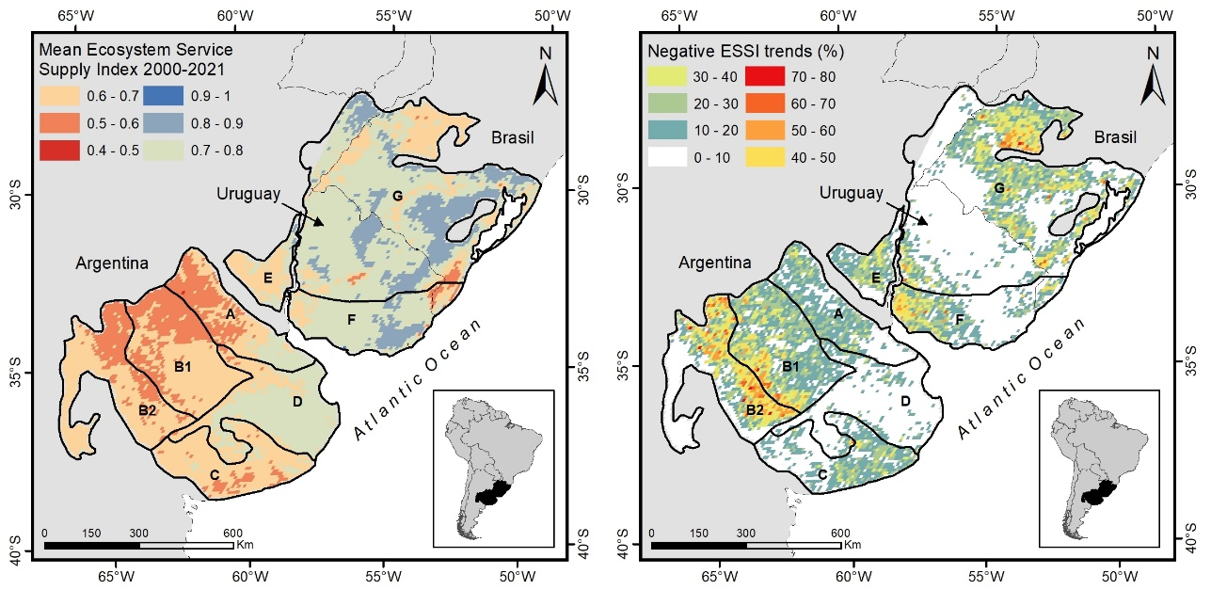
Fig. 5. Left: Mean Ecosystem Service Supply Index value (2000-2021), and Right: percentage of negative significant trends (over a 10x10 km grid) in the Ecosystem Service Supply Index over the period 2001-2021 for the Río de la Plata Grasslands. Letters denotes different sub-regions of Río de la Plata Grasslands: (A) Rolling Pampa. (B1) Flat Inland Pampa, (B2) West Inland Pampa, (C) Austral Pampa, (D) Flooding Pampa, (E) Mesopotamic Pampa, (F) Southern Campos, (G) Northern Campos.

Human Appropriation of Net Primary Production

The Human Appropriation of Net Primary Production (HANPP) quantifies the portion of ecosystems NPP used directly or indirectly by humans (Vitousek et al. 1986), and it reflects the changes in available energy for the trophic web (Field, 2001). HANPP incorporates two aspects of agricultural intensification described above, increases in cultivated area, and increases in crop yield. Several works have shown the relationship between HANPP and biodiversity (Wright, 1990; Haberl, 1997; Haberl et al. 2004), changes in atmospheric composition (DeFries et al. 1999; Schimel, 2000) water cycles (Gerten et al. 2005), or the provision of ecosystem services (Daily, 1997; Millennium Ecosystem Assessment, 2005). The central role on energy flow and its linkage with other ecosystem processes make HANPP a comprehensive indicator of human impact on ecosystems

Haberl et al. (1997) defined HANPP as the sum of the harvested Net Primary Production (NPP) and the differences in NPP due to land use changes. HANPP result from the difference between the NPP in the absence of human influence (NPP of potential vegetation: NPP₀) and the NPP of the actual vegetation remaining after harvest (NPP_{REM}). NPP_{REM} was calculated as the NPP of the current vegetation (NPP_{ACT}) minus the harvested NPP (NPP_{H}), directly appropriated by humans as agricultural products (grain, wood, meat, etc.) or destroyed during harvest (Fig 6, Eq 1)

HANPP = NPP₀−NPP_{REM} = NPP₀−(NPP_{ACT}−NPP_{H}) (1)

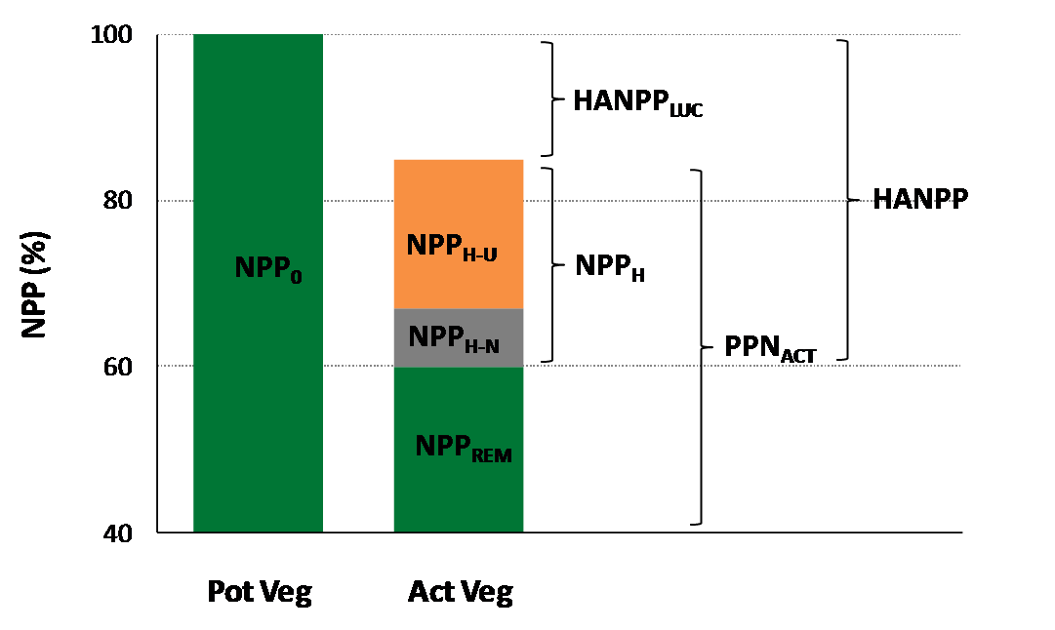
Fig 6: Components involved in Human Appropriation of Net Primary Productivity (HANPP) calculation. NPP₀: NPP of potential vegetation (Pot Veg); NPP_{ACT}: NPP of the current vegetation; NPP_{REM}: NPP of current vegetation remaining after harvest; NPP_{H}: harvested NPP; NPP_{H-U}: harvested NPP used by humans as agricultural products (grain, wood, meat, etc.); NPP_{H-N}: harvested NPP not used (Crop residues, underground biomass); HANPP_{LUC}: HANPP due to land-use changes.

The difference between NPP₀ and NPP_{ACT} represents HANPP due to land-use changes (HANPP_{LUC}), so HANPP can also be formulated as (Eq. 2):

HANPP = NPP_{H} + HANPP_{LUC} (2)

Baeza & Paruelo (2018) used medium resolution land-use and land-cover maps and NPP estimates from sub-national level agricultural statistics, and remotely sensed data modelling to calculate the HANPP for the entire Río de la Plata Grasslands in two periods that encompass a strong agricultural intensification process, 2001-2002 and 2012-2013. They found that more than 40% of RPG NPP is appropriated every year (and used directly or indirectly) by humans, a percentage much higher than that found in other regions of the world (see for example: Vitousek et al. 1986; Rojstaczer et al. 2001; Haberl et al. 2007). HANPP increased from 42% of potential NPP on 2001-2001 to 46.5 % on 2012-2013 due to the strong process of agricultural intensification that took place in the RPG. HANPP was highest in agricultural and forestry foci where it may exceed 70–80% and it was mainly associated with increases in harvested NPP due to both the expansion of the cultivated area and the crop yields (Fig. 7).

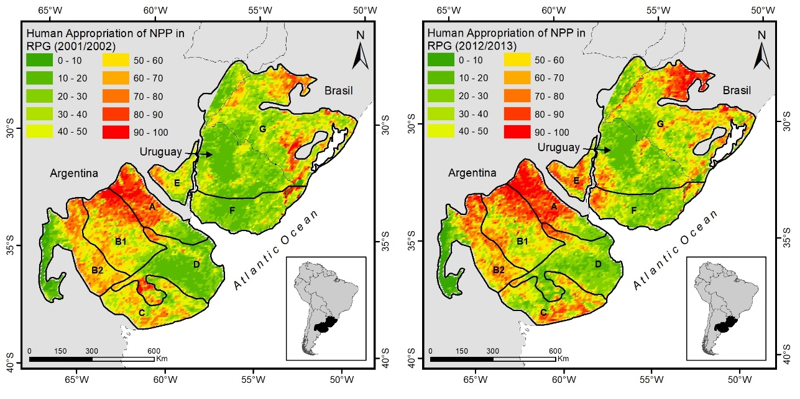

Fig 7: Human Appropriation of Net Primary Productivity (HANPP) in the Río de la Plata Grasslands region, expressed as a percentage of Net Primary Productivity of potential vegetation for 2001-2002 and 2012-2013. Letters denotes different sub-regions of Río de la Plata Grasslands: (A) Rolling Pampa. (B1) Flat Inland Pampa, (B2) West Inland Pampa, (C) Austral Pampa, (D) Flooding Pampa, (E) Mesopotamic Pampa, (F) Southern Campos, (G) Northern Campos.

Maximum HANPP average values for the different RPG sub-regions occurred in the Rolling Pampa, reaching 8.338 and 8.291 kgDM ha⁻¹ year⁻¹ for 2001-2002 and 2012-2013 respectively. Minimum average values occurred in Southern Campos during 2001-2002 (4.070 kgDM ha⁻¹ year⁻¹) and in Flooding Pampa during 2012-2013 (4.199 kgDM ha⁻¹ year⁻¹). The largest increases occurred on both sides of the Uruguay River (Mesopotamic Pampa, West of Southern Campos and southwest of Northern Campos), the North-western half of the Rolling Pampa, east of the Southern Pampa, north of the Northern Campos, some sectors of the Inland Pampa (Flat and West) and northwest of the Northern Campos (the Brazilian side of the Argentina-Brazil border) (Fig. 7).

EXPECTED LAND-USE AND LAND-COVER CHANGES

Using the MapBiomas Pampa land-use and land-cover maps, we described the transition probabilities p_{i->j} between land-use and land-cover types considering two study periods (2000-2010 and 2010-2019, Fig. 8). This allows us to estimate the annual rates of change and at which land-use and land-cover types expense the changes occurred. We overlapped the two period’s maps to obtain the transitions between land-use and land-cover types. We analysed the main transformations occurred in the RPG over the last decades: a) grassland to cropland (G->Cr) and b) grassland to afforestation (G->Af) (Baldi & Paruelo, 2008; Baeza & Paruelo, 2018; Baeza et al. 2022). We then intersected these transition maps with a 10 × 10 km grid to calculate the transition probabilities as (Eq. 3):

$P_{i→j,k}=\frac{A_{i→j,k}}{A_{i,t=0, k}}×\frac{1}{∆t}$ (3)
where A_{i} is the initial (at t = 0) area occupied by land-use and land-cover type i, A_{i->j} is the area of transition class i->j during 𝛥t (the time period in years), and k is a grid cell.

In average, for the whole region, transition probabilities from grassland to cropland were 0.038 and 0.33 for the 2000-2010 and 2010-2019 periods, respectively. The transition probability from grassland to afforestation were 0.013 and 0.015, for the 2000-2010 and 2010-2019 periods, respectively.

At RPG sub-regions level, the transition probabilities were different according to the land-use and land-cover types and the period of study. For the 2000-2010 period, the Argentine Pampas showed the highest annual probability of changing to cropland (average p_{G->Cr} = 0.055), particularly, the Mesopotamic Pampa, Rolling Pampa, and West and Flat Inland Pampa (Table 2). On the other hand, for the 2010-2019 period, only the Austral Pampa, the Mesopotamic Pampa, and the Flooding Pampa showed high probabilities of change (Table 2). The rest of the sub-regions showed low transition probabilities (average p_{G->Cr} = 0.024).

Grassland showed the highest annual probability of changing to afforestation in the Southern Campos and Northern Campos for both, the 2000-2010 and 2010-2019 periods (Table 2). The rest of the sub-regions showed very low values for both periods (average 2000-2010, p_{G->Af} = 0.0003; average 2010-2019, pG->Cr = 0.0004).
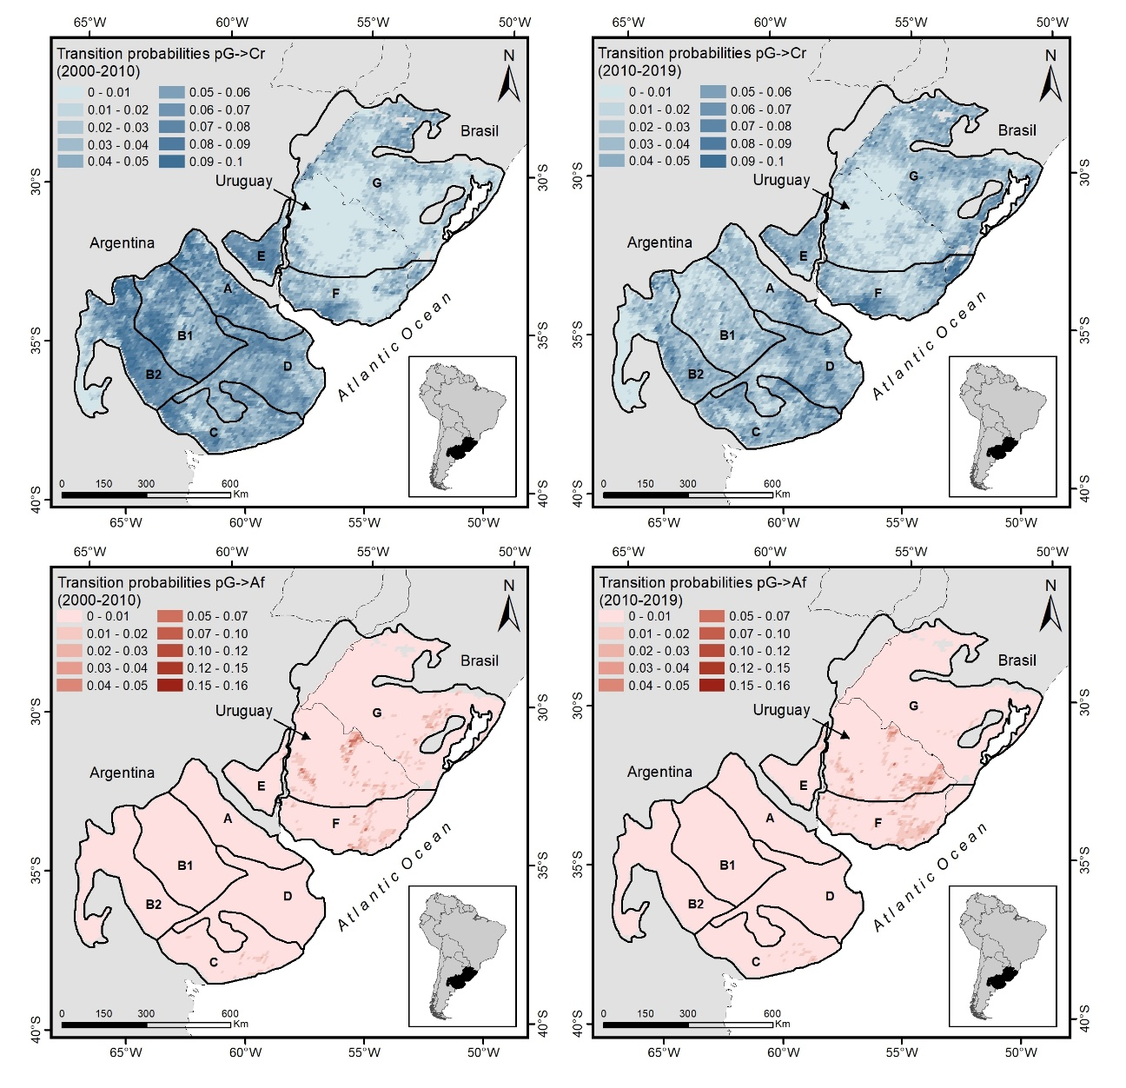
Fig. 8. Transition probabilities for grassland to cropland (pG->Cr, blue) and grassland to afforestation (pG->Af, orange) in the RPG for 2000-2010 and 2010-2019. Letters denotes different sub-regions of the RPG: (A) Rolling Pampa. (B1) Flat Inland Pampa, (B2) West Inland Pampa, (C) Austral Pampa, (D) Flooding Pampa, (E) Mesopotamic Pampa, (F) Southern Campos, (G) Northern Campos

Table 2: Transition probabilities from grassland to afforestation (p_{G->Af}) and grassland to cropland (p_{G->Cr}) for each RPG sub-region and for the two periods under study (2000-2010 and 2010-2019).

Sub-Region | 2000-2010 |  | 2010-2019
 | p_{G->Af} | p_{G->Cr} | p_{G->Af} | p_{G->Cr}
Northern Campos | 0,00234 | 0,01626 | 0,00209 | 0,02416
Southern Campos | 0,00340 | 0,02740 | 0,00535 | 0,03639
Austral Pampa | 0,00122 | 0,05023 | 0,00138 | 0,04187
West Inland Pampa | 0,00001 | 0,05692 | 0,00007 | 0,03045
Flat Inland Pampa | 0,00010 | 0,05632 | 0,00014 | 0,02408
Flooding Pampa | 0,00003 | 0,04860 | 0,00006 | 0,03827
Mesopotamic Pampa | 0,00058 | 0,06118 | 0,00061 | 0,04078
Rolling Pampa | 0,00007 | 0,05684 | 0,00006 | 0,03111

Considering the trends observed in relation to the transition probability, an increase in afforestation area is expected, particularly in the Northern and Southern Campos, and a neutral or even retracting trend in the transition from grassland to croplands, particularly in the Argentinean pampas where most of natural grasslands have been transformed already.

Final considerations
More than 50% of the RPGs were already transformed. Natural habitats and grasslands were reduced to small relicts in many of the subregions (i.e., the Rolling Pampas). The Northern and Southern Campos in Uruguay and Brazil concentrate most of the remaining temperate grasslands in South America. The probability of an area of grassland being replaced by annual crops is more than twice as high as that of being replaced by tree plantations. Both the area covered by grasslands and the probability of being replaced differed markedly among subregions indicating that aside from environmental controls, land-use and land-cover distribution is strongly influenced by social, economic, and technological factors, which in turn are affected by national policies.

The functional diversity at the landscape level, the Ecosystem Service Supply Index and the Human Appropriation of Net Primary Productivity clearly and objectively showed the consequences of the replacement of grassland by croplands and afforestation’s. The grasslands replacement with croplands generates a homogenization of Ecosystem Functioning and the loss of functional diversity. The supply of ES sharply decreased in those areas transformed into croplands. The absence of temporal trends in ES supply was associated to the preservation of natural habitats. Finally, Human Appropriation of Net Primary Productivity increased 4.5% over the entire region between 2001-2002 and 2012-2013. Appropriation surpassed the 70–80% of the Net Primary Productivity of potential vegetation (NPP₀) in agricultural and afforested areas. On average the HANPP on the grasslands areas is less than 11%, values substantially lower than the regional average (42%).

Supplementary material

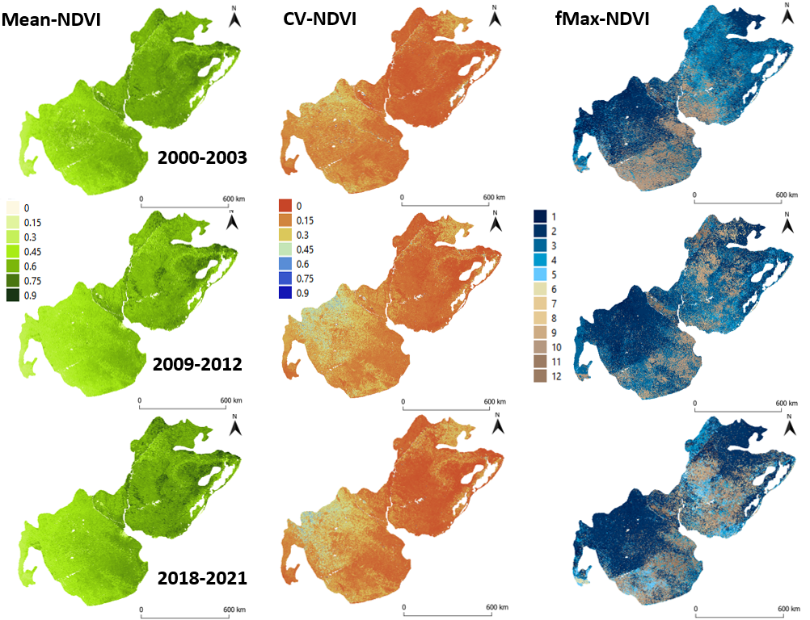
Fig. S1: Ecosystem Functional Attributes (“phenometrics”): NDVI_{MEAN}, NDVI_{CV} and NDVI_{fMax} representing the Productivity, Seasonality and Phenology of Río de la Plata Grasslands. fMax values expressed are the month in which the maximum value of NDVI was registered.

References

Alcaraz-Segura, D., Paruelo, J. M., and Cabello, J. (2006). Identification of current ecosystem functional types in the Iberian Peninsula. Global Ecology and Biogeography. 15, 200-212.
Alcaraz-Segura, D., Paruelo, J. M., Epstein, H. E., and Cabello, J. (2013). Environmental and human controls of ecosystem functional diversity in temperate South America. Remote Sensing. 5, 127-154.
Andrade, B. O., Bonilha, C. L., Overbeck, G. E., Vélez‐Martin, E., Rolim, R. G., Bordignon, S. A. L., Schneider, A. A, Vogel, E. C., Lucas, D. B., Garcia, E. N., dos Santos, E. D., Torchelsen, F. P., Vieira, M. S., Silva Filho, P. J. S., Ferreira, P. M. A., Trevisan, R., Hollas, R., Campestrini, S., Pillar, V. D. and Boldrini, I. I. (2019). Classification of South Brazilian grasslands: Implications for conservation. Applied Vegetation Science. 22: 168-184.
Baeza, S. and Paruelo, J. M. (2018). Spatial and temporal variation of Human Appropriation of Net Primary Production in the Rio de la Plata Grasslands. ISPRS Journal of Photogrammetry and Remote Sensing. 145: 238 – 249.
Baeza, S. and Paruelo, J, M. (2020). Land use/land cover change (2000–2014) in the Rio de la Plata grasslands: an analysis based on MODIS NDVI time series. Remote Sensing. 12, 381.
Baeza, S., Vélez-Martin, E., De Abelleyra, D., Banchero, S., Gallego, F., Schirmbeck, J., Verón, S., Vallejos, M., Weber, E., Oyarzabal, M., Barbieri, A., Petek, M., Guerra Lara, M., Sarrailhé, S. S., Balsi, G., Bagnato, C., Bruzzone, L., Ramos, S. and Hasenack, H. (2022). Two decades of land cover mapping in the Río de la Plata grassland region: The MapBiomas Pampa initiative. Remote Sensing Applications.: Society and Environment, 28, 100834.
Baldi, G. and Paruelo, J. M. (2008). Land-use and land cover dynamics in South American temperate grasslands. Ecology and Society, 13.
Burkhard, B., Kroll, F., Nedkov, S., and Müller, F. (2012). Mapping ecosystem service supply, demand, and budgets. Ecological Indicator. 21, 17-29.
Camba-Sans, G., Verón, S. R. and Paruelo, J. M. (2021). Forest strips increase connectivity and modify forests’ functioning in a deforestation hotspot. Journal of Environmental Management. 290, 112606.
Cordeiro, J. L. and Hasenack, H. (2009). Cobertura vegetal atual do Rio Grande do Sul. In: Pillar, V. P.; Müller, S.C.; de Souza Castihos, Z. M. and Avila, A.V. [Eds.]. Campos Sulinos–conservação e uso sustentável da biodiversidade. Brasília: Ministério do Meio Ambiente, Brasil. 285-299 p.
Daily, G. C. (1997). Introduction: What are ecosystem services? In G. Daily, (Ed.). Nature’s Services: Societal Dependence on Natural Ecosystems. Island Press, Washington, D.C. 1-10 p.
DeFries, R. S., Field, C. B., Fung, I., Collatz, G. J. and Bounoua, L. (1999). Combining satellite data and biogeochemical models to estimate global effects of human‐induced land cover change on carbon emissions and primary productivity. Global Biogeochemical Cycles. 13, 803-815.
Ellis, E. C., Goldewijk, K. K., Siebert, S., Lightman, D., and Ramankutty, N. (2010). Anthropogenic transformation of the biomes, 1700 to 2000. Global Ecology and Biogeography. 19, 589-606.
Englund, O., Berndes, G., & Cederberg, C. (2017). How to analyse ecosystem services in landscapes—A systematic review. Ecological Indicators. 73, 492-504.
Field, C. B. (2001). Global change: Enhanced: Sharing the garden. Science. 294, 2490–2491.
Foley, J. A., DeFries, R., Asner, G. P., Barford, C., Bonan, G., Carpenter, S. R., Chapin, F. S., Coe, M. T., Daily, G. C., Gibbs, H. K., Helkowski, J. H., Holloway, T., Howard, E. A., Kucharik, C. J., Monfreda, C., Patz, J. A., Prentince, I. C., Ramankutty, N. and Snyder, P. K. (2005). Global consequences of land use. Science. 309, 570-574.
Forman, R. T. (1995). Land Mosaics: The Ecology of Landscapes and Regions. Cambridge University Press.
Gallego F., Paruelo, J. M., Baeza, S. and Altesor A. (2020). Distinct ecosystem types respond differentially to grazing exclosure. Austral Ecology. 45, 548-556.
Gerten, D., Hoff, H., Bondeau, A., Lucht, W., Smith, P. and Zaehle, S. (2005). Contemporary “green” water flows: simulations with a dynamic global vegetation and water balance model. Physics and Chemistry of the Earth, Parts A/B/C. 30, 334-338.
Graesser, J., Aide, T. M., Grau, H. R. and Ramankutty, N. (2015). Cropland/pastureland dynamics and the slowdown of deforestation in Latin America. Environmental Research Letters. 10, 034017.
Guerschman, J. P., Paruelo, J. M. and Burke, I. C. (2003). Land use impacts on the normalized difference vegetation index in temperate Argentina. Ecological applications. 13, 616-628.
Haberl, H. (1997). Human appropriation of net primary production as an environmental indicator: implications for sustainable development. AMBIO. 26:143-146.
Haberl, H., Wackernagel, M., Krausmann, F., Erb, K. H. and Monfreda, C. (2004). Ecological footprints and human appropriation of net primary production: a comparison. Land use policy. 21, 279-288.
Haberl, H., Erb, K. H., Krausmann, F., Gaube, V., Bondeau, A., Plutzar, C., Gingrich, S., Lucht, W. and Fischer-Kowalski, M. (2007). Quantifying and mapping the human appropriation of net primary production in earth´s terrestrial ecosystems. Proceedings of the National Academy of Sciences. 104, 12942–12947.
Hesselbarth, M. H., Sciaini, M., With, K. A., Wiegand, K. and Nowosad, J. (2019). landscapemetrics: an open‐source R tool to calculate landscape metrics. Ecography. 42, 1648-1657.
Hoekstra, J. M., Boucher, T. M., Ricketts, T. H. and Roberts, C. (2005). Confronting a biome crisis: global disparities of habitat loss and protection. Ecology letters. 8, 23-29.
IPBES. (2019). Summary for policymakers of the global assessment report on biodiversity and ecosystem services of the Intergovernmental Science-Policy Platform on Biodiversity and Ecosystem Services. S. Díaz, J. Settele, E. S. Brondízio, H. T. Ngo, M. Guèze, J. Agard, A. Arneth, P. Balvanera, K. A. Brauman, S. H. M. Butchart, K. M. A. Chan, L. A. Garibaldi, K. Ichii, J. Liu, S. M. Subramanian, G. F. Midgley, P. Miloslavich, Z. Molnár, D. Obura, A. Pfaff, S. Polasky, A. Purvis, J. Razzaque, B. Reyers, R. Roy Chowdhury, Y. J. Shin, I. J. Visseren-Hamakers, K. J. Willis, and C. N. Zayas (eds.). IPBES secretariat, Bonn, Germany. 56 pages.
https://doi.org/10.5281/zenodo.3553579
Jullian, C., Nahuelhual, L. and Laterra, P. (2021). The Ecosystem Service Provision Index as a generic indicator of ecosystem service supply for monitoring conservation targets. Ecological Indicators. 129, 107855.
Lezama, F., Pereira, M., Altesor, A. and Paruelo, J. M. (2019). Grasslands of Uruguay: classification based on vegetation plots. Phytocoenologia. 49: 211-229.
Mapbiomas Pampa (2021). MapBiomas Pampa Trinacional Colección 1.0. Available at: https://pampa.mapbiomas.org/es/statistics [Accessed November 30, 2021].
McNaughton, S. J., Oesterheld, M., Frank, D. A. and Williams, K. J. (1989). Ecosystem-level patterns of primary productivity and herbivory in terrestrial habitats. Nature. 341, 142-144.
Millennium Ecosystem Assessment. (2005). Ecosystems and Human Well Being, Synthesis. Island, Washington, DC.
Ministerio de Ambiente. (2022). Reporte Final. Huella de la Ganadería en Uruguay https://www.gub.uy/ministerio-ambiente/comunicacion/publicaciones/reporte-final-huella-ganaderia-uruguay [Accessed April 5, 2023].
Monteith, J. L. (1972). Solar radiation and productivity in tropical ecosystems. Journal Applied Ecology. 9:747–66.
Noss, R. F. (1990). Indicators for monitoring biodiversity: a hierarchical approach. Conservation Biology. 4, 355-364.
Oyarzabal, M., Andrade, B., Pillar, V. D. and Paruelo, J. M. (2020). Temperate Subhumid Grasslands of Southern South America. In: Goldstein, M. I. and DellaSala, D. A. (Eds). Encyclopaedia of the World's Biomes, Elsevier. 577-593 p.
Overbeck, G. E., Müller, S. C., Fidelis, A., Pfadenhauer, J., Pillar, V. D., Blanco, C. C., Boldrini, I. I., Both, R. and Forneck, E. D. (2007). Brazil's neglected biome: the South Brazilian Campos. Perspectives in Plant Ecology, Evolution and Systematics. 9: 101-116.
Paruelo, J. M. and Lauenroth, W. K. (1998). Interannual variability of NDVI and its relationship to climate for North American shrublands and grasslands. Journal of Biogeography. 25, 721-733.
Paruelo, J. M., Jobbágy, E. G. and Sala, O. E. (2001). Current distribution of ecosystem functional types in temperate South America. Ecosystems. 4, 683-698.
Paruelo, J. M., Texeira, M., Staiano, L., Mastrángelo, M., Amdan, L., and Gallego F. (2016). An integrative index of Ecosystem Services provision based on remotely sensed data. Ecological Indicators. 71, 145-154.
Paruelo, J. M., Oesterheld, M., Altesor, A., Piñeiro, G., Rodríguez, C., Baldassini, P., Irisarri, G., López-Mársico, L., and Pillar, V. D. (2022). Grazers and fires: Their role in shaping the structure and functioning of the Río de la Plata Grasslands. Ecología Austral. 32, 784–805. https://doi.org/10.31219/osf.io/p2hkz
Paruelo, J. M., and Sierra, M. (2022). Sustainable intensification and ecosystem services: how to connect them in agricultural systems of southern South America. Journal of Environmental Studies and Sciences, 1-9.
Perelman, S. B., León, R. J. C. and Oesterheld, M. (2001). Cross-scale vegetation patterns of Flooding Pampa grasslands. Journal of Ecology. 89: 562-577.
Pettorelli, N. (2013). The Normalized Difference Vegetation Index. Oxford University Press, Oxford.
Piñeiro, G., Oesterheld, M. and Paruelo, J. M. (2006). Seasonal variation in aboveground production and radiation-use efficiency of temperate rangelands estimated through remote sensing. Ecosystems. 9, 357-373.
Raudsepp-Hearne, C., Peterson, G. D. and Bennett, EM. (2010). Ecosystem service bundles for analyzing tradeoffs in diverse landscapes. Proceedings of the National Academy of Sciences. 107, 5242-5247.
Rojstaczer, S., Sterling, S. M. and Moore, N. J. (2001). Human appropriation of photosynthesis products. Science. 294: 2549-2552.
Schimel, D., Melillo, J., Tian, H., McGuire, AD., Kicklighter, D., Kittel T., Rosenbloom, N., Running, S., Thornton, P., Ojima, D., Parton, W., Kelly, R., Sykes, M., Neilson, R. and Rizzo, B. (2000). Contribution of increasing CO2 and climate to carbon storage by ecosystems in the United States. Science. 287, 2004-2006.
Soriano, A., León, R. J. C., Sala, E. O., Lavado, R. S., Dereguibus, V. A., Cahuepé, M. A., Scaglia, O. A., Velázquez, C. A. and Lemcoff, J. H. (1991). Rio de la Plata Grasslands. In: Coupland (ed.) Ecosystems of the world 8A. Natural grasslands. Introduction and Western Hemisphere. 1st edn. New York. Elsevier. 367-407 p
Souza, C. M., Shimbo, J., Rosa, M. R., Parente, L. L., Alencar, A., Rudorff, B. F. T., Hasenack, H., Matsumoto, M., Ferreira, L., Souza-Filho, P. W. M., de Oliveira, S. W., Rocha, W. F., Fonseca, A. V., Marques, C. B., Diniz, C. G., Costa, D., Monteiro, D., Rosa, E. R., Vélez-Martin, E., Weber, E. J., Lenti, F. E. B., Paternost, F. F., Pareyn, F. G. C., Siqueira, J. V., Viera, J. L., Neto, L. C. F., Saraiva, M. M., Sales, M. H., Salgado, M. P. G., Vasconcelos, R., Galano, S., Mesquita, V. V. and Azevedo, T. (2020). Reconstructing Three Decades of Land Use and Land Cover Changes in Brazilian Biomes with Landsat Archive and Earth Engine. Remote Sensing. 12, 2735
Staiano, L., Camba-Sans, G., Baldassini, P., Gallego, F., Texeira, M. and Paruelo, J. M. (2021). Putting the Ecosystem Services idea at work: Applications on impact assessment and territorial planning. Environmental Development. 38, 100570.
Verón, S. R., Blanco, L. J., Texeira, M. A., Irisarri, J. G. N. and Paruelo, J. M. (2018). Desertification and ecosystem services supply: The case of the Arid Chaco of South America. Journal of Arid Environments. 159, 66-74.
Vitousek, P. M., Ehrlich, P. R., Ehrlich, A. H. and Matson, P. A. (1986). Human appropriation of the products of photosynthesis. BioScience. 36, 368-373.
Volante, J., Mosciaro, J., Morales Poclava, M., Vale, L., Castrillo, S., Sawchik, J., Tiscornia, G., Fuente, M., Maldonado, I., Vega, A., Trujillo, R., Cortéz, L. and Paruelo, J. M. (2015). Expansión agrícola en Argentina, Bolivia, Paraguay, Uruguay y Chile entre 2000-2010. Caracterización espacial mediante series temporales de índices de vegetación. RIA. Revista de investigación Agropecuaria. 41: 179-191.
Watson, J. E., Jones, K. R., Fuller, R. A., Marco, M. D., Segan, D. B., Butchart, S. H., Allan, J. R., McDonald-Madden, E. and Venter, O. (2016). Persistent disparities between recent rates of habitat conversion and protection and implications for future global conservation targets. Conservation Letters. 9, 413-421.
Weyland, F., Baudry, J. and Ghersa C. (2019). Short‐term effects of a severe drought on avian diversity and abundance in a Pampas Agroecosystem. Austral Ecology. 44, 1340-1350.
Wright, D. H. (1990). Human impacts on energy flow through natural ecosystems and implications for species endangerment. AMBIO. 19, 189–194.
Wu, J. (2006). Landscape ecology, cross-disciplinarity, and sustainability science. Landscape Ecology, 28, 1-4.
Wu, J. (2013). Landscape sustainability science: ecosystem services and human well-being in changing landscapes. Landscape Ecology, 28, 999-1023.

