Design of simplified hybrid compounds with potential antiproliferative activity.

Vanesa Quintana¹, Juan I. Padrón^{2,3}, Víctor S. Martín², José M. Padrón², Danilo Davyt¹ and Guillermo Valdomir^{1*}
1) Department of Organic Chemistry, Facultad de Química, UdelaR, Montevideo, Uruguay
2) Instituto Universitario de Bio-Orgánica “Antonio González” (IUBO-AG), Centro de Investigaciones Biomédicas de Canarias (CEBICAN), Universidad de La Laguna, La Laguna, España
3) Instituto de Productos Naturales y Agrobiología CSIC, La Laguna, España
*e-mail: valdomir@fq.edu.uy

Keywords: hybrid compounds, antiproliferative, molecular analysis.

Introduction
During previous studies, we have developed several hybrid compounds combining tetrahydropyrans with oxa and thiazols. These compounds exhibited interesting selective antiproliferative activity against a set of human tumour cell lines.^{1,2} As part of our process to produce new compounds with better activity, we decided to simplify the structures and substitute the building block less active (oxazole). Therefore, we used the on-line software LLAMA (Lead-Likeness And Molecular Analysis) to generate a library of compounds and theoretically evaluate their properties to be a potential lead compound.³
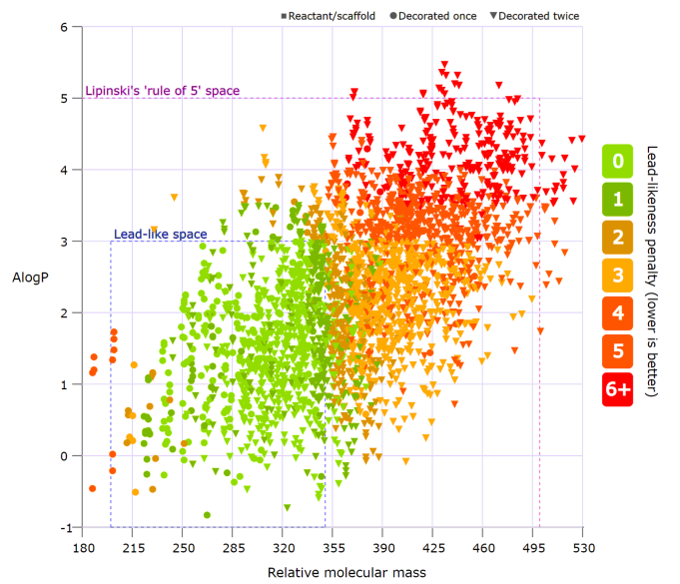
Figure 1. Library of compounds obtained with LLAMA.

LLAMA software generates new compounds adding different “decorations” into a base structure. After comparing some of the compounds with anticancer products from the literature, we proposed a new series of hybrid compounds to be prepared, combining tetrahydropyrans wit different aromatic rings and N-heterocycles.
Results and Discussion
The production of the new series of compounds started with the preparation of three new tetrahydropyrans that can afterwards be combined via click chemistry with different blocks containing aromatic rings and N-heterocycles.
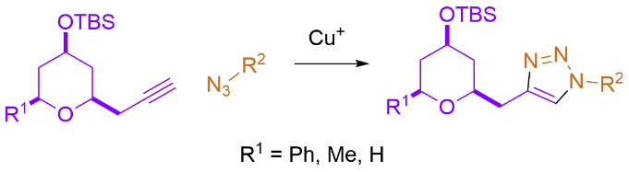
Figure 2. Procedure to obtain the hybrid compounds.

The obtained compounds will be assayed against a panel of 6 human tumour cell lines and also against non tumour cells in order to determine their activity and selectivity.
Conclusion
So far, we have obtained several new hybrids within this new group but antiproliferative analysis is still pending.
Acknowledgements
We would like to acknowledge ANII, PEDECIBA, CSIC and Alexander von Humboldt Foundation for the financial support.
References
1. Valdomir, G.; Fernández, M. dl Á.; Lagunes, I.; Padrón, J. I.; Martín, V. S.; Padrón, J. M.; Davyt, D. New J. Chem. 2018, 42, 13784-13789.
2. Quintana V.; González-Bakker, A.; Padrón, J. I.; Martín, V. S.; Padrón, J. M.; Davyt, D.; Valdomir, G. Eur. J. Org. Chem. 2022, 2022, e202200528.
3. Colomer, I.; Empson, C. J.; Craven, P.; Owen, Z.; Doveston, R. G.; Churcher, I.; Marsden, S. P.; Nelson, A. Chem. Commun. 2016, 52, 7209-7212. https://llama.leeds.ac.uk/.
.

