Staying hooked: effective science engagement and communication in recreational fisheries

Pablo Pita¹, Sean Tracey², Robert Arlinghaus^{3,4}, Eneko Bachiller⁵, Filipa Pinho-Duarte⁶, Keno Ferter⁷, Filipe Henriques^{6,8}, Samantha Hook⁹, Kieran Hyder¹⁰, Alejo Irigoyen¹¹, María P. Jiménez¹², Martín Laporta^{13,14}, Adam M. Lejk¹⁵, Eoin Leonard¹⁶, Hans Jakob Olesen¹⁷, Freya Palmer¹⁸, Mišo Pavičić¹⁹, João Pontes²⁰, Marta Pujol-Baucells^{21,22}, Zachary Radford¹⁰, Mafalda Rangel²⁰, William Roche¹⁶, Hannah Rudd²³, Diarmuid Ryan¹⁶, Valerio Sbragaglia²², Jules Selles²⁴, Catarina NS Silva²⁵, Christian Skov²⁶, Harry V. Strehlow²⁷, Stephen Taylor⁸⁹, Pedro Veiga²⁰, Leonardo A. Venerus¹¹, Paul Venturelli²⁹, David Vertegaal³⁰, Marc Simon Weltersbach²⁷, Martin Wiech⁷, Alexander Winkler³¹.

¹ CICA - Centro Interdisciplinar de Química e Bioloxía, Departamento de Bioloxía, Universidade da Coruña, A Coruña, Spain.
² Institute for Marine and Antarctic Studies, University of Tasmania, Hobart, Australia.
³ Department of Fish Biology, Fisheries and Aquaculture, Leibniz Institute of Freshwater Ecology and Inland Fisheries, Berlin, Germany.
⁴ Division of Integrative Fisheries Management, Faculty of Life Sciences and Integrative Research Institute on Transformations of Human-Environment Systems, Humboldt-Universität zu Berlin, Berlin, Germany.
⁵ AZTI, Marine Fisheries and Ecosystem Sampling and Data Collection (ItsasData), Basque Research and Technology Alliance (BRTA), Sukarrieta, Spain.
⁶ Direção de Serviços de Monitorização, Estudos e Investigação do Mar, Direção Regional de Pescas, Funchal, Portugal.
⁷ Institute of Marine Research, Bergen, Norway.
⁸ MARE–Marine and Environmental Sciences Centre/ARNET–Aquatic Research Network, ARDITI Regional Agency for the Development of Research, Technology and Innovation, Funchal, Portugal.
⁹ Substance Ltd, Manchester, United Kingdom.
¹⁰ Centre for Environment, Fisheries and Aquaculture Science, Lowestoft, United Kingdom.
¹¹ CESIMAR - Centro para el Estudio de Sistemas Marinos, CCT CONICET-CENPAT - Centro Cientifico Tecnologico, Consejo Nacional de Investigaciones Científicas y Técnicas, Centro Nacional Patagonico, Puerto Madryn, Argentina.
¹² Spanish Institute of Oceanography (IEO, CSIC). Centro Oceanográfico de Cádiz, Spain.
¹³ Dirección Nacional de Recursos Acuáticos, Ministerio de Ganadería, Agricultura y Pesca, Rocha, Uruguay.
¹⁴ Campus DoMar, International Campus of Excellence, Vigo, Spain.
¹⁵ National Marine Fisheries Research Institute, Gdynia, Poland.
¹⁶ Inland Fisheries Ireland, Dublin, Ireland.
¹⁷ Section for Monitoring and data, Technical University of Denmark, DTU Aqua, Lyngby, Denmark.
¹⁸ International Centre for Ecohydraulics Research, Faculty of Engineering and the Physical Sciences, Southampton, United Kingdom.
¹⁹ Institute of Oceanography and Fisheries, Split, Croatia.
²⁰ Centro de Ciências do Mar do Algarve (CCMAR/CIMAR LA), Universidade do Algarve, Faro, Portugal.
²¹ Institut Català de Recerca per a la Governança del Mar (ICATMAR), Barcelona, Spain.
²² Institute of Marine Sciences (ICM-CSIC), Barcelona, Spain.
²³ Angling trust, Leominster, United Kingdom.
²⁴ Consultant, Marseille, France.
²⁵ Centre for Functional Ecology - Science for People & the Planet (CFE), Associate Laboratory TERRA, Department of Life Sciences, University of Coimbra, Coimbra, Portugal.
²⁶ Section of Freshwater Fisheries and Ecology, Technical University of Denmark, DTU Aqua, Silkeborg, Denmark.
²⁷ Thünen Institute of Baltic Sea Fisheries, Rostock, Germany.
²⁸ Department of Primary Industries and Regional Development, Government of Western Australia, Perth, Australia.
²⁹ Ball State University, Muncie, Indiana, USA.
³⁰ Sportvisserij Nederland, Bilthoven, The Netherlands.
³¹ Department of Ichthyology and Fisheries Science, Rhodes University, Makhanda, South Africa.

SUPPLEMENTARY MATERIAL

Appendix I

Survey about communication preferences in marine recreational fisheries

As an expert in Marine Recreational Fisheries, we appreciate if you could answer this short questionnaire. We would like to know your ideas about how to improve the engagement among academics, managers and policymakers, recreational fishers, and other stakeholders, NGOs, and civil society. The questionnaire is made up of 8 sections with questions aimed at gathering your ideas about potential communication strategies and tools for the 4 main groups of receptors, to collect ideas about who should send the message, to understand factors to achieve efficient communication strategies, to know successful communication strategies that you are aware, and to understand professional and socioeconomic patterns of your choices. The survey has been designed exclusively for scientific purposes, and the results will be made public.

The questionnaire is anonymous, and you will not be asked for any personal information that can be used to identify you. AII information received will be treated in strict compliance with the General Data Protection Regulation (EU regulation 2016/6 79) in Europe in relation to data protection and privacy.

Thank you very much for your participation.

Engaging with public managers and policymakers. Building a communication strategy aimed to disseminate news and results among technicians working in the management of wildlife and coastal areas, and policymakers.

1. Which do you think is the most effective channel for connecting with managers and policymakers? Please, also indicate the required frequency of the communications.

2. Please choose your preferred channel: Web site, Blog, Email, Newsletter, Webinars, Podcasts, Facebook, Twitter, YouTube, Pinterest, Instagram, Snapchat, Face-to-face meetings , Other.

3. If you selected "other", please explain.

4. Indicate how often they should be used: Daily, Weekly, Monthly, Every 6 months, One per year, Just after relevant news, results, or meetings.

Engaging with academics. Building a communication strategy aimed to disseminate news and results among scientists, researchers, and professors.

5. Which do you think is the most effective channel for connecting with academics? Please, also indicate the required frequency of the communications.

6. Please choose your preferred channel: Web site, Blog, Email, Newsletter, Webinars, Podcasts, Facebook, Twitter, YouTube, Pinterest, Instagram, Snapchat, Face-to-face meetings , Other.

7. If you selected "other", please explain.

8. Indicate how often they should be used: Daily, Weekly, Monthly, Every 6 months, One per year, Just after relevant news, results, or meetings.

Engaging with recreational fishers. Building a communication strategy aimed to disseminate news and results among recreational fishers.

9. Which do you think is the most effective channel for connecting with recreational fishers? Please, also indicate the required frequency of the communications.

10. Please choose your preferred channel: Web site, Blog, Email, Newsletter, Webinars, Podcasts, Facebook, Twitter, YouTube, Pinterest, Instagram, Snapchat, Face-to-face meetings , Other.

11. If you selected "other", please explain.

12. Indicate how often they should be used: Daily, Weekly, Monthly, Every 6 months, One per year, Just after relevant news, results, or meetings.

Engaging with other stakeholders, NGOs, and civil society. Building a communication strategy aimed to disseminate news and results among stakeholders, NGOs, and society in general.

13. Which do you think is the most effective channel for connecting with other stakeholders, NGOs, and civil society? Please, also indicate the required frequency of the communications.

14. Please choose your preferred channel: Web site, Blog, Email, Newsletter, Webinars, Podcasts, Facebook, Twitter, YouTube, Pinterest, Instagram, Snapchat, Face-to-face meetings , Other.

15. If you selected "other", please explain.

16. Indicate how often they should be used: Daily, Weekly, Monthly, Every 6 months, One per year, Just after relevant news, results, or meetings.

About the sender. Please, explain who should act as the originator of the communications.

17. Who should create and disseminate the communications?: Anyone involved in the generation of the information that is shared, or a hired communication specialist.

Best practices. We are interested in your assessment of key components to develop a successful communication strategy.

18. Please, can you indicate the degree of importance of the following solutions to develop efficient communication strategies? Please, score your answer from 1 (not at all important) to 5 (very important): Use of plain language (avoid jargon), Obtain feedback from the receptor, Use of different channels to the message, involve different stakeholders in projects, Involve different stakeholders in the communication strategy, Use of neutral facilitators in meetings, Other.

19. If you selected "other", please explain.

Examples of successful communication. We would appreciate if you could provide an example of a successful communication strategy.

20. Can you briefly explain the name of the initiative, what it consists of, and where we can find information about it?

About you. Finally, we need to know some information about you. Remember that this questionnaire is anonymous, and we do not collect any data that allows us to know your identity.

21. Please indicate your age.

22. Please indicate your gender: Man, Woman, I prefer not to say.

23. Please indicate your level of studies completed: Primary, Secondary, Technical training, University.

24. Which is your occupation?: Policymaker, Public manager, Scientist/researcher/professor, Self-employed, Employed, Retiree.

25. Are you a recreational fisher yourself?: No, I never fished in my life, I fish sometimes, I fish often, I fish a lot.
Appendix II

Expert opinion on successful communication strategies and on examples of good practices on how to improve public participation in marine recreational fisheries

As an esteemed Marine Recreational Fishing (MRF) expert, we value your insights on improving engagement within MRF in your area. Your responses will remain anonymous unless you choose to contribute as a co-author for a scientific paper. All data will adhere strictly to the General Data Protection Regulation (EU regulation 2016/679).

Thank you for your participation.

1. Please, write your name.

2. Please, write the name of your institution.

3. Please, write the name of your country.

4. In the case of a different country, please, write the country (and/or region) on which you will provide information on how to improve communication among actors, and about a case of study on good communication practices.

5. Please, share insights (1-3 paragraphs) on strategies to enhance engagement among academics, managers, policy makers, recreational fishers, and other stakeholders, including NGOs and civil society. For example, collaborative frameworks that prioritize mutual understanding, shared decision-making, and collective ownership of initiatives.

6. How certain are you about your ideas in the previous text? In a scale from 1, which means very unsure (information is based in personal perceptions), to 5, which means very sure (because you participated in initiatives, studies, and publications on this subject. Please, provide references).

7. Provide a brief example (1-3 paragraphs) of successful practices in enhancing stakeholder relationships in marine recreational fisheries, including web pages, actors, region, and achievements. For example, initiatives such as effective research dissemination, innovative approaches to recruit and retain fishers in research and management endeavors, or activities that led to significant shifts in stakeholders' attitudes or behaviors.

8. Did this initiative enhance?

Communication: by fostering effective channels and strategies for transparent information sharing among stakeholders.
Collaboration: by promoting joint efforts, resource pooling, and shared responsibilities towards common goals.
Participation: by actively involving stakeholders in decision-making, project planning, and implementation, fostering ownership and empowerment.
Co-creation: by facilitating the generation of ideas and solutions.
Co-innovation: by inspiring stakeholders to contribute innovative ideas and technologies.
Co-management: by empowering stakeholders to collectively govern shared resources.
Capacity building: by investing in stakeholder development to enhance engagement and contribution.
Conflict resolution: by addressing conflicts through constructive dialogue, mediation, and negotiation.
Empowerment: enabling marginalized groups to voice concerns and participate in decision-making.
Sustainability: by prioritizing engagement for long-term resilience and equitable outcomes.

9. How certain are you about your ideas in the previous text? In a scale from 1, which means very unsure (information is based in personal perceptions), to 5, which means very sure (you were involved in the initiative).

Appendix III

Table S1. Cases of study on marine recreational fisheries provided by members of the WGRFS in June 2024 as examples of communication and participation.
Case of study | Location | Goal | Further information
Adaptive Management | Denmark | Adaptive governance | https://www.aqua.dtu.dk/english/advice/monitoring-of-fish-stocks
Anglers’ Atlas | Canada | Data collection | https://www.anglersatlas.com/
Baltic Sea | Netherlands | Data collection | https://www.sportvisserijnederland.nl/vis-water/sportvisserijonderzoek/
Atlantic bluefin tuna fisheries | Norway | Data collection | https://www.hi.no/en/hi/news/2020/august/stangfisket-etter-verdens-storste-tunfisk-er-i-gang
Baltic Sea (Boddenhecht) | Germany | Adaptive governance | https://www.ifishman.de/en/projects/boddenhecht/overview-boddenpike/
Catchwise | United Kingdom | Data collection | https://catchwise.org/
Citizen Science Projects | Germany | Data collection | https://www.thuenen.de/en/thuenen-topics/fisheries/whats-the-catch-the-importance-of-marine-recreational-fisheries/development-of-the-german-data-collection-since-2003
Co-management | Spain | Adaptive governance | https://www.icatmar.cat/pesca/
Competitions | South Africa | Data collection | https://www.ru.ac.za/ichthyology/latestnews/takingsciencetorecreationalfishing.html
Data Collection | Croatia | Data collection | https://galijula.izor.hr/en/projekti/dcf/
DPesca | Spain | Data collection | https://www.ieo.es/es/rss/-/journal_content/56_INSTANCE_8N7BFzLKCD43/10640/7574699?refererPlid=10655
Eastern Cantabrian Sea | Spain | Data collection | https://www.azti.es/proyectos/pesquerias-recreativas-y-artesanales-recogida-de-datos-a-traves-de-nuevos-dispositivos-digitales/
FISKEPLEJE | Denmark | Engagement | https://www.fiskepleje.dk/service/english_version_fiskepleje
GT PMR | Spain | Engagement | https://pescamaritimarecreativa.udc.es
IMREC Diary | Ireland | Data collection | https://imrec-ifigeo.hub.arcgis.com/

Table S1. Cont.
Case of study | Location | Goal | Further information
Isla e Islote de Lobos MPA | Uruguay | Adaptive governance | https://www.gub.uy/ministerio-ambiente/comunicacion/publicaciones/decreto-n-233024-ingreso-isla-islote-lobos-entorno-sumergido
MadeiraGoFish | Portugal | Data collection | https://gofishram.madeira.gov.pt/
marEEshift | Germany | Adaptive governance | https://www.idiv.de/en/mareeshift.html
NMPAR-PV | Portugal | Adaptive governance | https://ampiccomprojeto.pt/
Omakala | Finland | Data collection | https://omakala.fi/
PESCARDATA | Portugal | Data collection | https://pescardata.pt/
Polish marine recreational fisheries | Poland | Adaptive governance | https://mir.gdynia.pl/monograph-on-the-95th-anniversary-of-the-national-marine-fisheries-research-institute-current-topics-of-research/?lang=en
Pollack FISP | United Kingdom | Adaptive governance | https://www.plymouth.ac.uk/research/marine-conservation-research-group/pollack-fisp
Peces y Pesca Deportiva Argentina | Argentina | Engagement | https://www.proyectoarrecife.com.ar/
Recfishing | European Union | Data collection | https://op.europa.eu/fr/publication-detail/-/publication/8b60e408-0123-11ee-87ec-01aa75ed71a1
 |  |  | https://op.europa.eu/en/publication-detail/-/publication/01f3d94d-4019-11eb-b27b-01aa75ed71a1
Rocky Reef Fishes Exhibition | Argentina | Environmental awareness | https://patagonianatural.org.ar/
Sea Angling Diary Project | United Kingdom | Data Collection | https://www.seaangling.org/
Select & Spear | Spain | Environmental awareness | https://youtu.be/tGu4fgrnAKM?si=zb2VSxxWsx1-3izM
SUYS & REDMAP | Australia | Data collection | What is Redmap? - Redmap
 |  |  | Send Us Your Skeletons
Systems Thinking | United Kingdom | Engagement | https://www.gov.uk/government/publications/systems-thinking-for-civil-servants/case-studies#case-study-1

Appendix IV

Figure S1. Detailed communication channel use in recreational fisheries, showing the average percentage of use by frequency across four groups—public managers and policymakers, researchers, recreational fishers, and other stakeholders (including NGOs and civil society)—with channels color-coded by type (refer to Figure 2 for additional details).
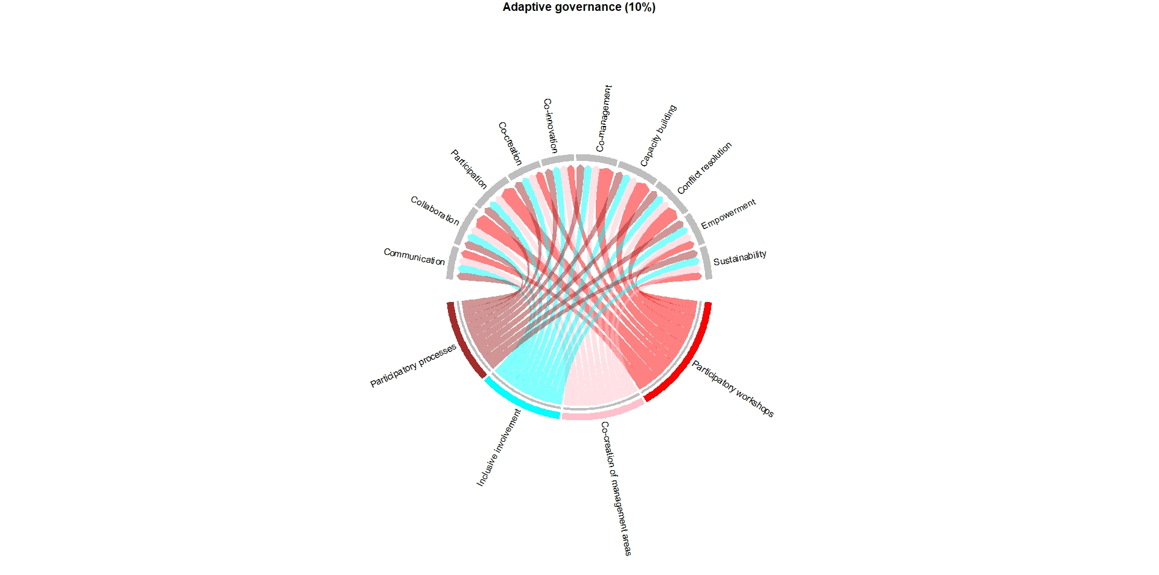
Figure S2. Key relationships between communication strategies designed to foster adaptive governance (shown at the bottom, highlighted in colors) employed in 29 case studies on marine recreational fisheries and their associated outcomes (displayed at the top). The thickness of each connecting line reflects the strength of the relationship, determined by both frequency and certainty levels. Percentage in parentheses denotes the proportion of the aggregated score for the displayed connections relative to the overall total. Refer to Figure 4 for additional details.
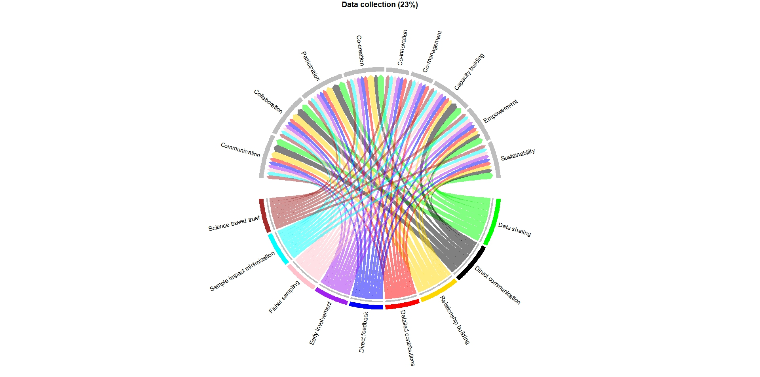
Figure S3. Key relationships between communication strategies designed to foster data collection (shown at the bottom, highlighted in colors) employed in 29 case studies on marine recreational fisheries and their associated outcomes (displayed at the top). The thickness of each connecting line reflects the strength of the relationship, determined by both frequency and certainty levels. Percentage in parentheses denotes the proportion of the aggregated score for the displayed connections relative to the overall total. Refer to Figure 4 for additional details.

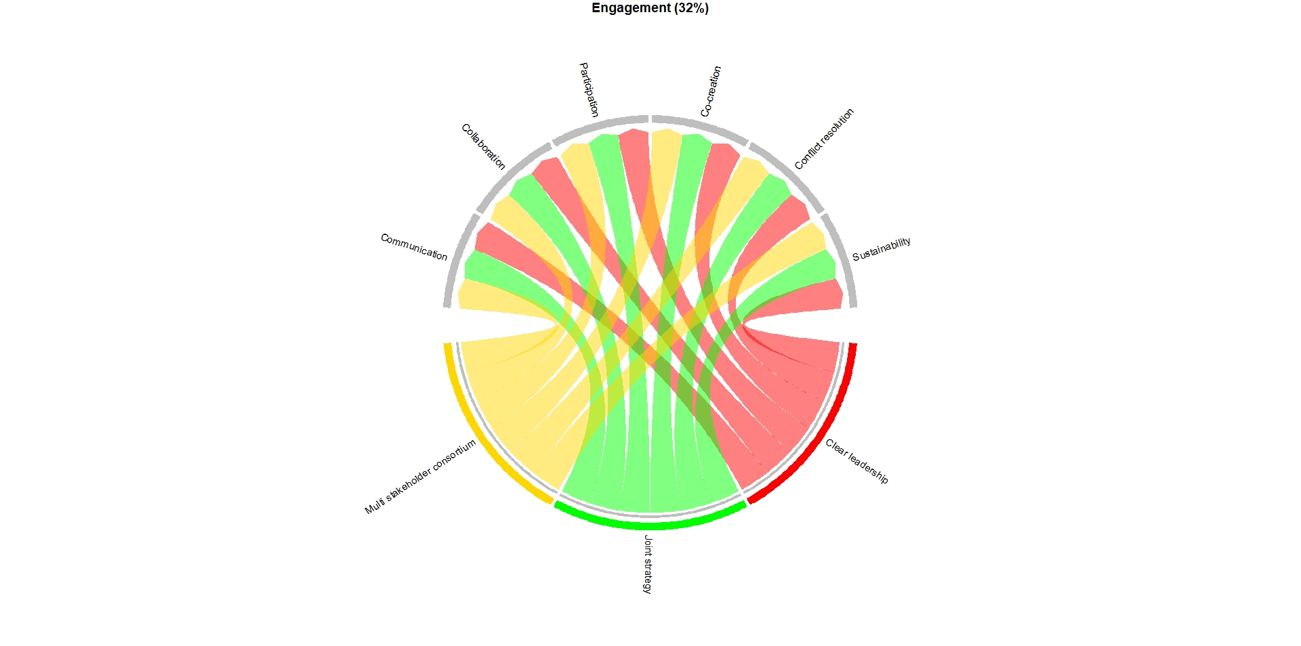
Figure S4. Key relationships between communication strategies designed to foster engagement (shown at the bottom, highlighted in colors) employed in 29 case studies on marine recreational fisheries and their associated outcomes (displayed at the top). The thickness of each connecting line reflects the strength of the relationship, determined by both frequency and certainty levels. Percentage in parentheses denotes the proportion of the aggregated score for the displayed connections relative to the overall total. Refer to Figure 4 for additional details.

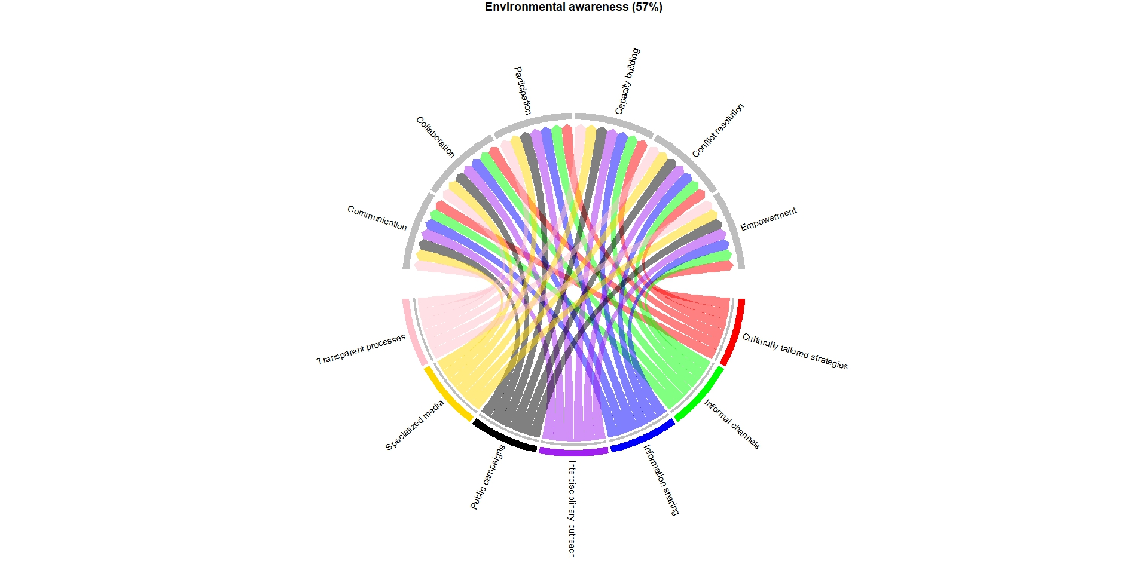
Figure S5. Key relationships between communication strategies designed to foster environmental awareness (shown at the bottom, highlighted in colors) employed in 29 case studies on marine recreational fisheries and their associated outcomes (displayed at the top). The thickness of each connecting line reflects the strength of the relationship, determined by both frequency and certainty levels. Percentage in parentheses denotes the proportion of the aggregated score for the displayed connections relative to the overall total. Refer to Figure 4 for additional details.

