Structural and magnetic properties of two complexes based on Re(IV) and 3d metal ions

M. Martirena Otero¹, A. Grenni¹, N. Moliner², J. Cano², L. Suescun³, C. Rojas¹, R. González¹
¹ Área Química Inorgánica, Universidad de la República, Montevideo, Uruguay
² Instituto de Ciencia Molecular, Universidad de Valencia, Valencia, Spain
³Cryssmat-Lab, Universidad de la República, Montevideo, Uruguay
E-mail: mmartirena@fq.edu.uy

Thematic Area: Materials Chemistry
Keywords: Coordination chemistry, Crystallography, Molecular Magnetism.

Molecular magnetism is an on-growing area of research that has been interlinked with several subareas of chemistry and physics such as coordination and supramolecular chemistry, solid-state physics, and crystallography, among others. Historically most research has been focused on 3d and 4f metal complexes, however, this leaves out other metals as possible spin carriers.^{[1,2]} In this regard, rhenium(IV) opens a new vary of possibilities, excelling among the heavy transition elements due to its S = ³/₂ spin configuration and its high spin-orbit coupling constant. Adding up to this, rhenium(IV) complexes have high magnetic anisotropy of the ground state, making them an interesting choice of metalloligands by designing a complex able to coordinate to another metal center.
This work describes the synthesis as well as the structural and magnetic characterization of novel compounds obtained from using the ligand N,N-bis(3-methoxy salicylidene) hydrazine (H₂hydva) and rhenium(IV) metaloligands. For the synthesis, the polydentate H₂hydva ligand is firstly obtained by condensing o-vanillin with hydrazine. Once isolated, H₂hydva is reacted with 3d ions, and additionally a rhenium(IV) metalloligand (able to coordinate to the 3d ion) is added to increase the nuclearity of the compounds. Finally, the structural and magnetic properties of the complexes have been studied.
Hence, details of the structural and magnetic characterization of the heteropolynuclear compounds are presented here. An example of one of the obtained compounds can be found in Figure 1. The hexanuclear complex has four Mn(II) centers, two [ReBr₅(H^{i}nic)]⁻ units (H^{i}nic = isonicotinic acid) and three hydva²⁻ ligands.
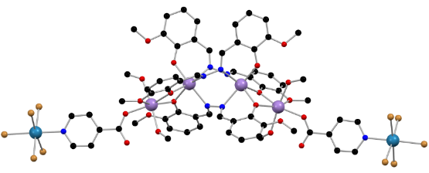
Figure 1. Molecular structure of Compound 1. Colour code: Mn, lilac; Re, turquoise; Br, orange; O, red; N, blue; C, black. Hydrogen atoms are omitted for a better view.
Acknowledgments: Agencia Nacional de Investigación e Innovación (ANII).
References
[1] Ferrando-Soria, J. et al. Coordination Chemistry Reviews, 339, 17–103 (2017).
[2] Coronado, E. Nature Reviews Materials, 5(2), 87-104 (2020).

